SAP – Project Systems
&
Investment Management

Training/Process Document

Contents
1. Create Investment program (Control Period) 4
2. Create Appropriate Request 5
3. Create Position ID 10
4. Assign Position ID to Appropriation Request 11
5. Create Measure or Scheme from the Proposal 12
6. Assign Budget to Position ID and Scheme 13
6.1 Assign Budget to Position ID 13
6.2 Assign Budget to Scheme 14
7. Create Scheme Structure 15
8. Easy Cost Planning 17
9. Workflow for Cost Estimates 18
19
10. Create Purchase Requisition from Estimates 20
11. Create ROW Purchase Requisition 22
12. M-BOOK 23
A. Create M-BOOK – Only for DEs 24
B. Search for M-BOOK 24
C. Create and Submit M-BOOK Page 25
D. Material account statement – 221Q 27
E. Approve or Check Measure M-BOOK Page – Only for ADEs, Des 29
13. Service Entry Sheet 30
A. Search Service Entry Sheet 30
B. Create Service Entry Sheet 31
C. Create Seignorage Report 34
D. Contractor Acceptance for SES – FORM14 35
E. Penalties, Recoveries Report 36
F. Service Entry wise Material Account Statement 40
G. Workflow for Service Entry Sheet only for ADEs and DEs. 42
14. Tower Schedule form Upload – AETs, ADETs and DETs 43
15. Physical Progress – AEs, ADEs 45
16. Reports & T-Codes 47

  - Introduction
This guide is designed to document the process and good practice of existing Business AP Transco processes. About the Tutorial Project System (PS) is one of the key modules of SAP to perform project and portfolio management. It helps you to manage the project life cycle starting from structuring to planning, execution, until the project completion. Audience SAP PS helps to manage and support all the SAP projects in a company. Project System is a source to organization for planning, scheduling, collecting, and generating Assets and expenditure over a project period.
Recommended Users – Construction Wing, Transmission Wing, Civil wing, IT & Telecom, TRE Wing.
- Chief Engineers
- Superdendent Engineers
- Divisional Engineers
- Divisional Engineers (Technical)
- Assistant Divisional Engineers
- Assistant Divisional Engineers (Technical)
- Assistant Engineers
- Assistant Engineers (Technical)

Create Investment program (Control Period)
T- Code – IM01
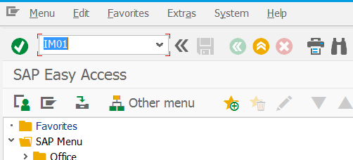

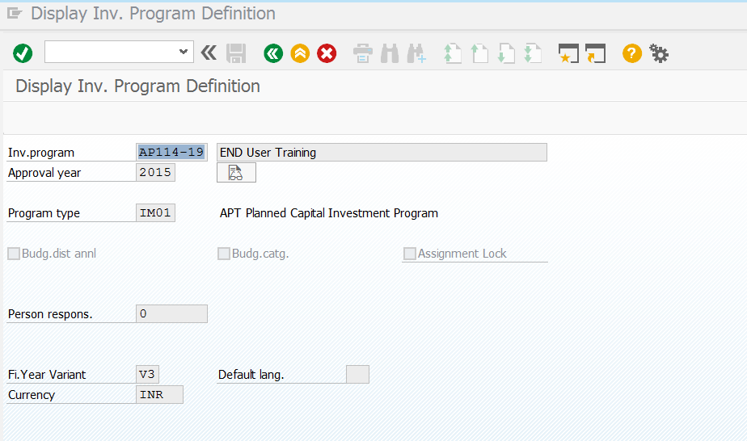
1.7
1.5
1.4
1.3
1.1
1.6
1.2
  - Create Control Period ID for Ex:- APT14-19
  - Write the Description for Program (Control Period)
  - Approval Year – Which Program created year for Ex:- 2014-15 to 2019-20 approval year is 2014
  - Select Program Type from F4
  - Uncheck Budg. dist annl Check Box
  - Select Fi.Year Variant from F4 for Ex:- APR to Mar with Special Periods 4
  - Select Currency INR

Create Appropriate Request
T- Code – IMA11 – In Legacy this is called Proposal, after Field Feasibility report this proposal will be prepared with High Level Estimate by responsible CE Wing.
The Coding Mask of the Proposal and Scheme defined such a way that Proposal (Appropriation Request), Scheme (Project Definition,Level1 WBS) and Project (Level2 WBS) Coding will be the same.
c

b

a

- SI represents Proposal Type
- Represents Year of the Proposal For Ex:- 16 or 17
- Represents of the next sequence number of the that proposal in that year
Below are Proposals Types (Appropriation Request Types)
  - Select appropriate Proposal Type as mentioned below

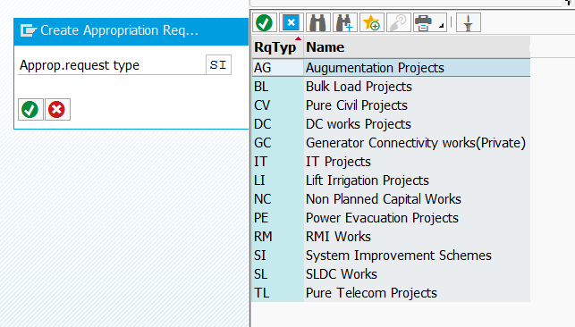
2.1
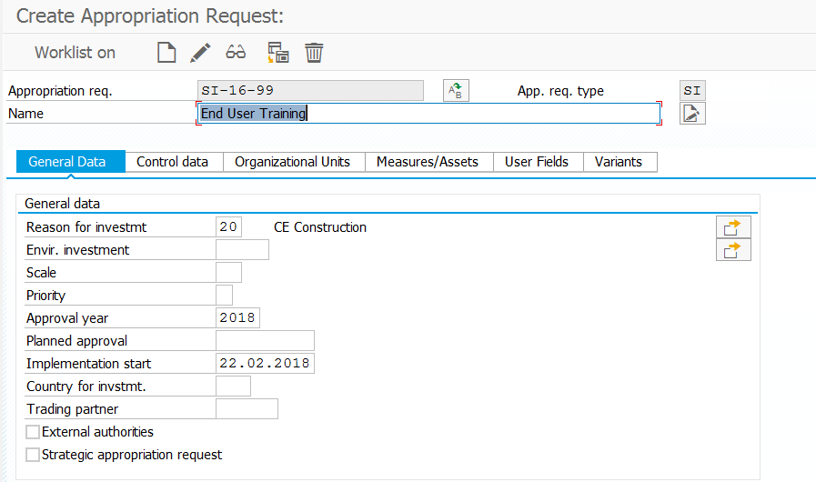
2.6
2.3
2.2
2.7
2.5
2.4

  - Select the Proposal sequence number
  - Write the description of the Proposal maximum 40 Characters
  - Click on the Icon and Paste the long text of the Proposal
  - Select from F4 responsible CE for this Proposal
  - The year of the proposal approved
  - Tentative Implementation start date of the Scheme
Select the Variants Tab
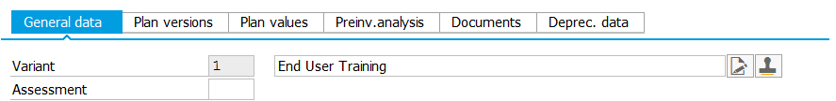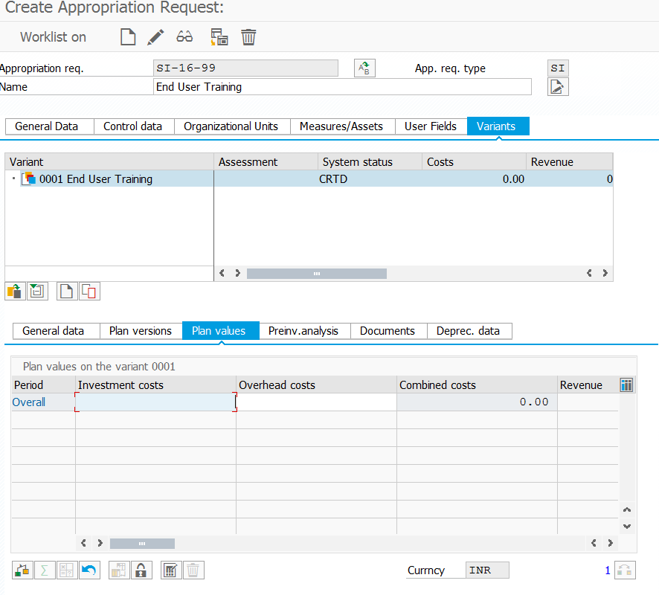
2.11
2.10.1
2.12
2.10
2.9
2.8
15.6

2.10.1

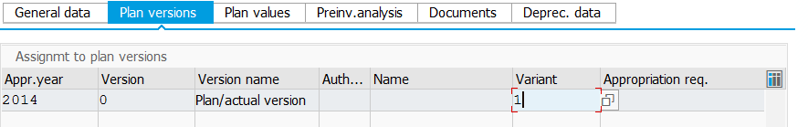

  - Write the Description of the Variant, this is like First proposal or second Proposal
  - Select Variants Tab
  - Select Plan values Tab
    - Select Plan Versions tab and Select Variant from F4
  - If you want to put direct Lumpsum Cost can be used this field otherwise go to step
  - Select icon for High Level Estimate.
  - Select Show/Hide Item view as mentioned below
  - Select “V” - Variable from F4
  - Select Choose Layout which is suitable or Select Change Layout for Own
  - Write the Description Maximum40 Characters in Description field it it is more write in Remarks field.
2.13
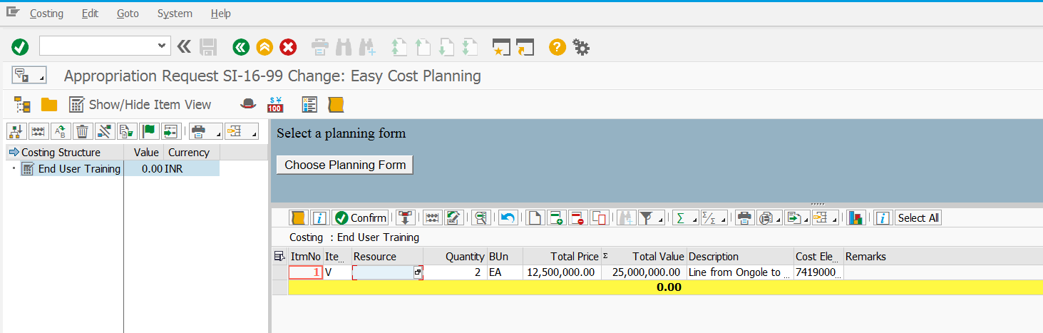
2.16
2.15
2.14

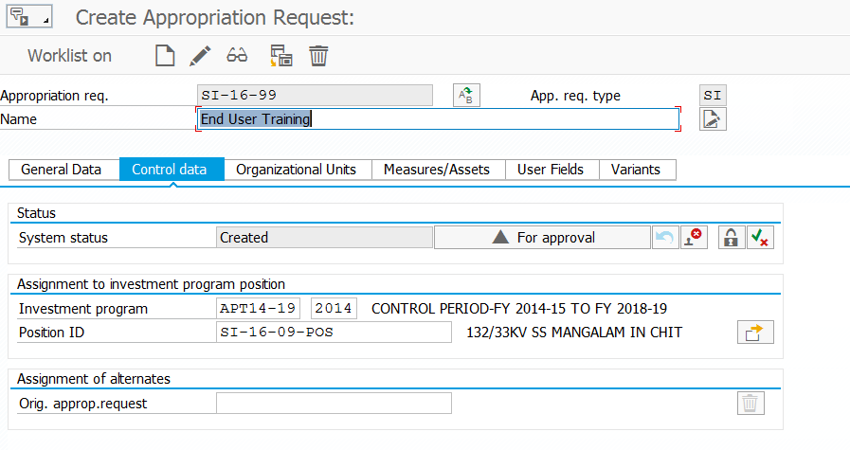
2.18
2.17
  - Select Control data Tab
  - Send for approval
After Step2.18 WORKFLOW will be triggered and can be seen in immediate reporting officer Inbox as shown below.
W1. Select icon and Search in Inbox for suitable item
W2. Click on attachment for High Level estimate

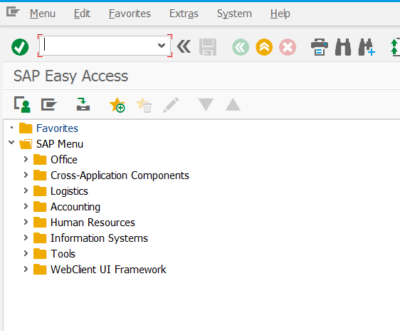
W1

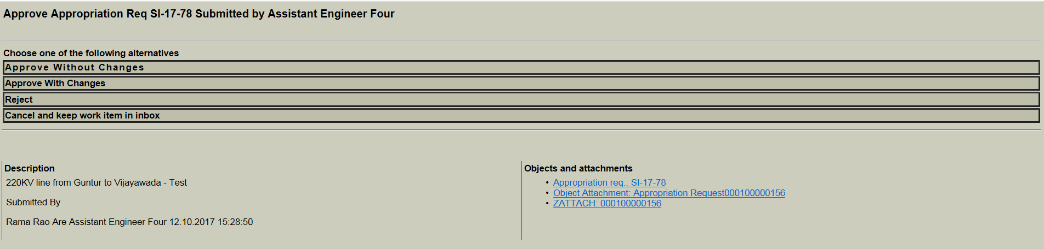
W2

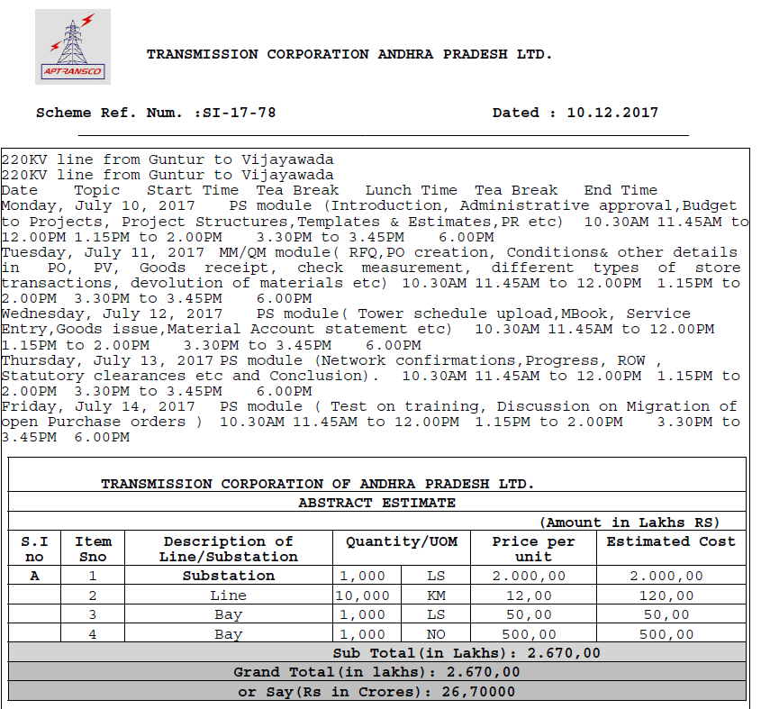

After Approval of the High level estimate create Position ID.

Create Position ID
T Code – IM22, Select the node which is suitable.

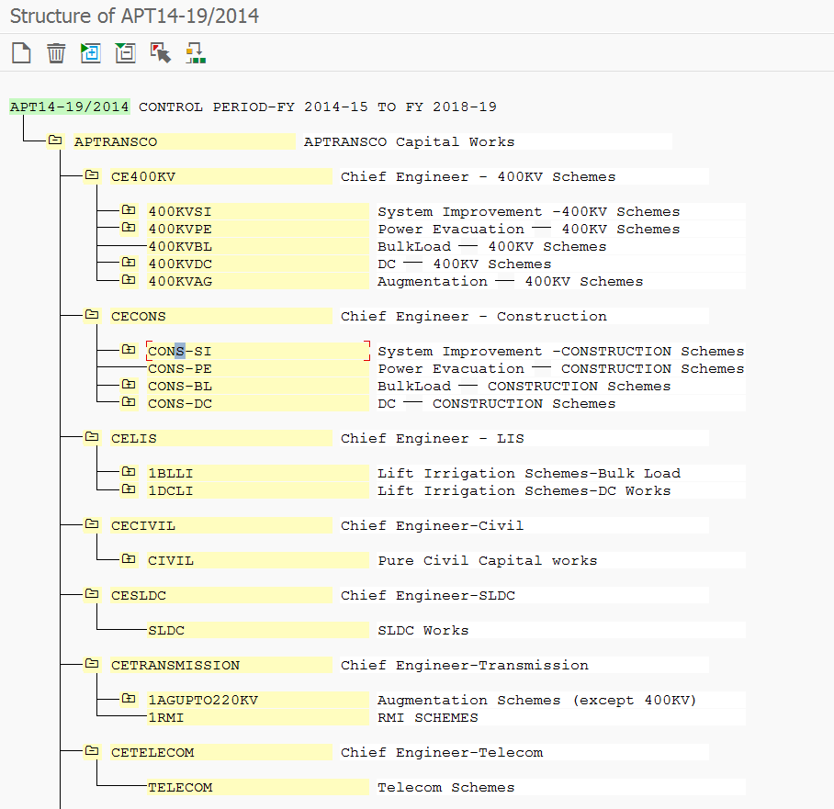
3.3
3.2
3.1
  - Select Suitable Program to create Position ID
  - Expand IM structure and select suitable node to create Position ID
  - Click on Icon to create Position ID
  - Create Position ID code same as Scheme ID with the extension of “-POS” for easy identification in structure
  - Click on Check button and Copy button

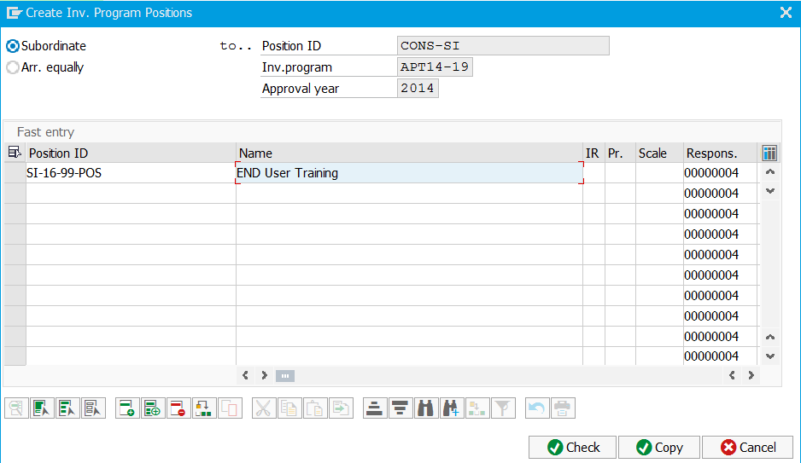
3.4
3.5

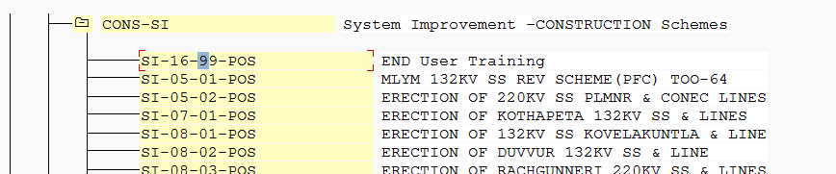

Assign Position ID to Appropriation Request
After Position ID creation assign to Appropriation Request T code IMA11 with Change icon.
  - Select Investment Program and Suitable Position ID and Then SAVE

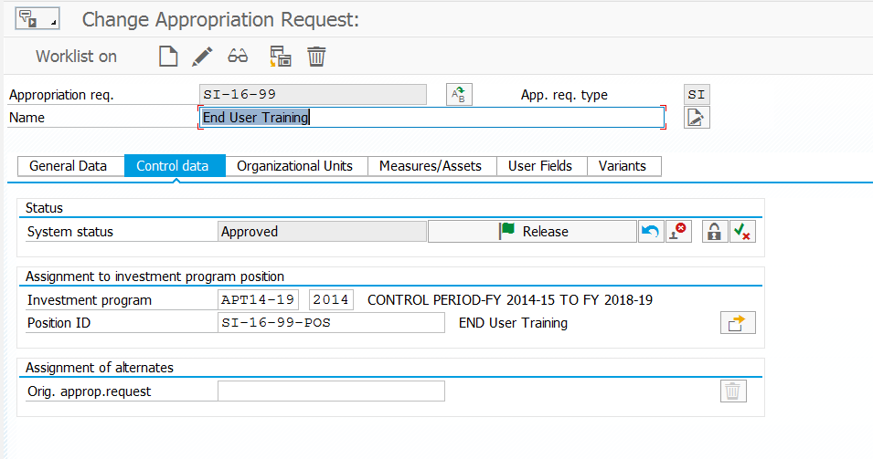
4.1

Create Measure or Scheme from the Proposal
T-Code IMA11 in Change Mode—Go to Measures Tab.
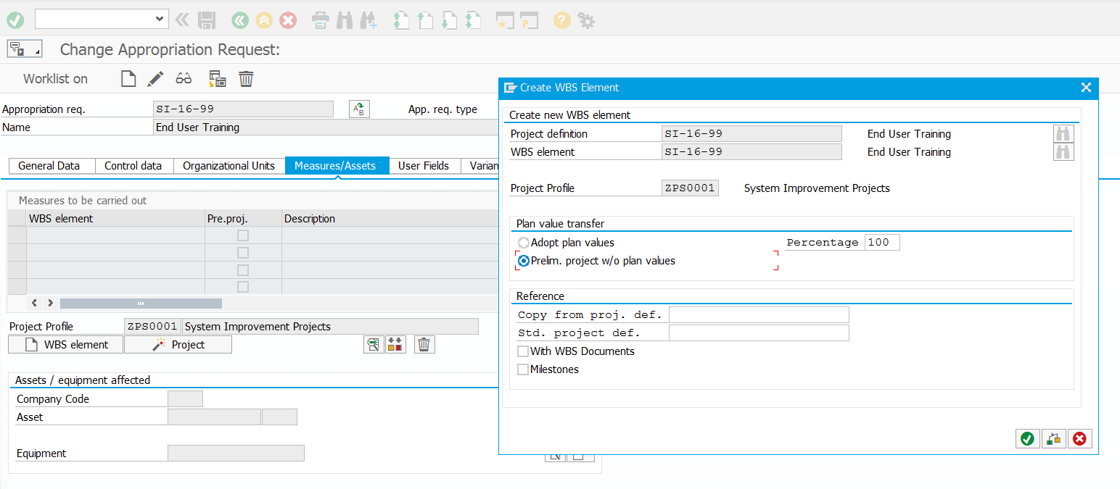
5.2
5.1

  - Click on WBS Element button
  - Select Prelim.Project W/O plan Values because detail estimate will be done later

Assign Budget to Position ID and Scheme

Assign Budget to Position ID
T- Code IM32.
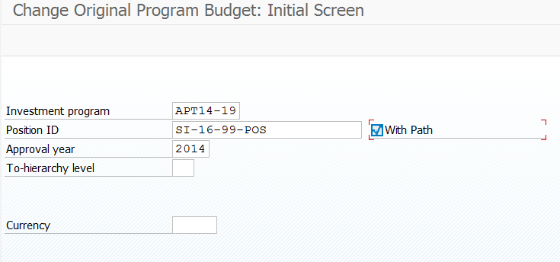
6.1.2
6.1.1
6.1.3
    - Select Program from F4
    - Select Position ID from F4 or Type in the field
    - Check “With Path” Check Box
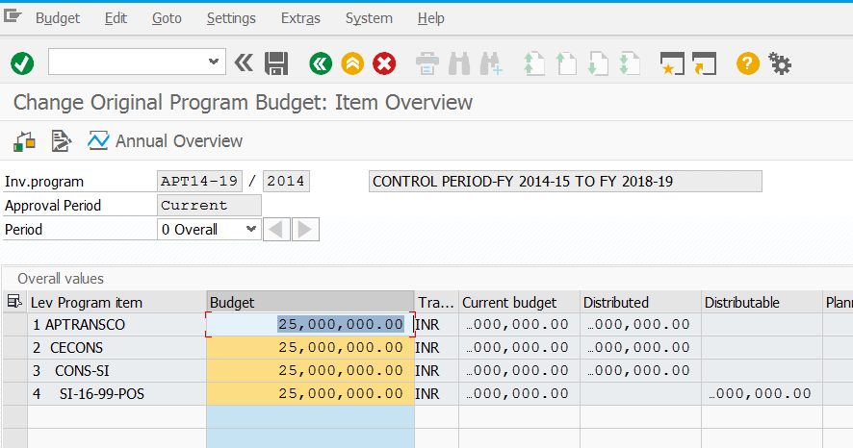
6.1.6
6.1.7
6.1.4
6.1.8
6.1.5

    - Enter Administrative approved amount in Position ID
    - Select Budget Column
    - Select Edit button in the menu bar Select Total UP-Select total Values
    - Cilck on Check button – Make sure no errors found
    - Click on Save button

  - Assign Budget to Scheme
T Code IM52
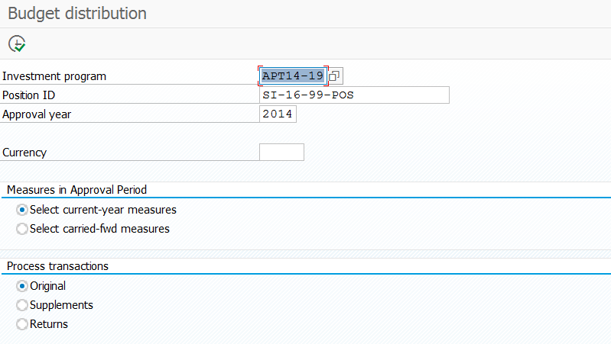
6.2.4
6.2.1
6.2.3
6.2.2
    - Select Program from F4
    - Select Position ID and then Click on Clock button
    - Select suitable Radio button
    - Select Suitable Radio button and then Click on Clock button

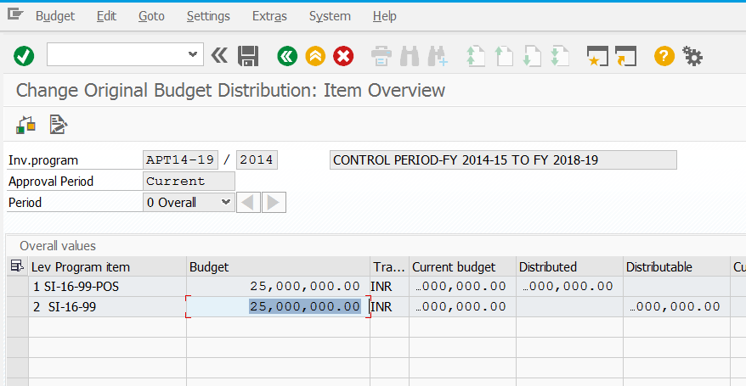
6.2.7
6.2.6
6.2.5
    - Enter approved amount not more than Position ID amount
    - Check and make sure no errors found
    - Click on Save

Create Scheme Structure
T Code CJ20n.
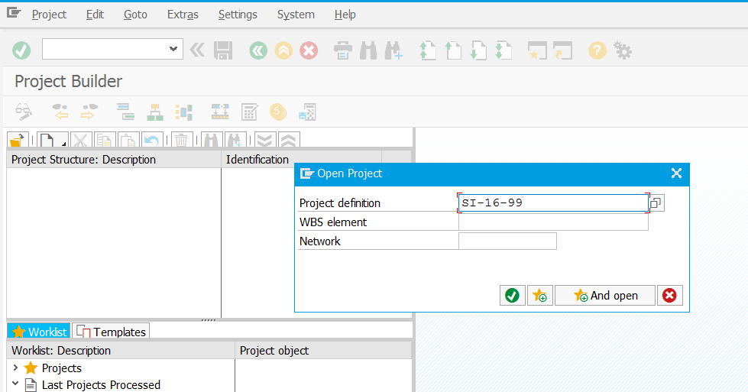
7.2
7.1
  - Click on icon

  - Enter Scheme ID in Project Definition Field
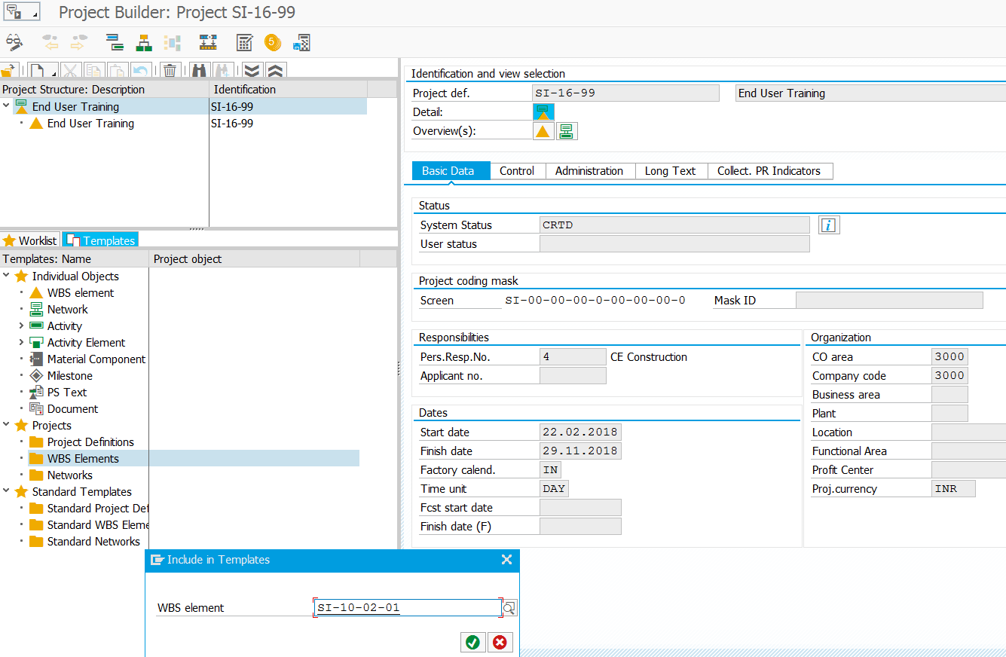
7.8
7.7
7.6
7.5
7.3
7.4

  - Select Suitable person Responsible for the Scheme
  - Tentative or Agreed Completion date of the scheme
  - Select the Tab of Templates
  - Select WBS Element
  - Select suitable template or any existing project suits to you
  - Select Level1 WBS
  - Select Template , Drag and Drop at Level1 WBS
  - Select level2 WBS
  - Select suitable Project Type on Right hand side of the pane

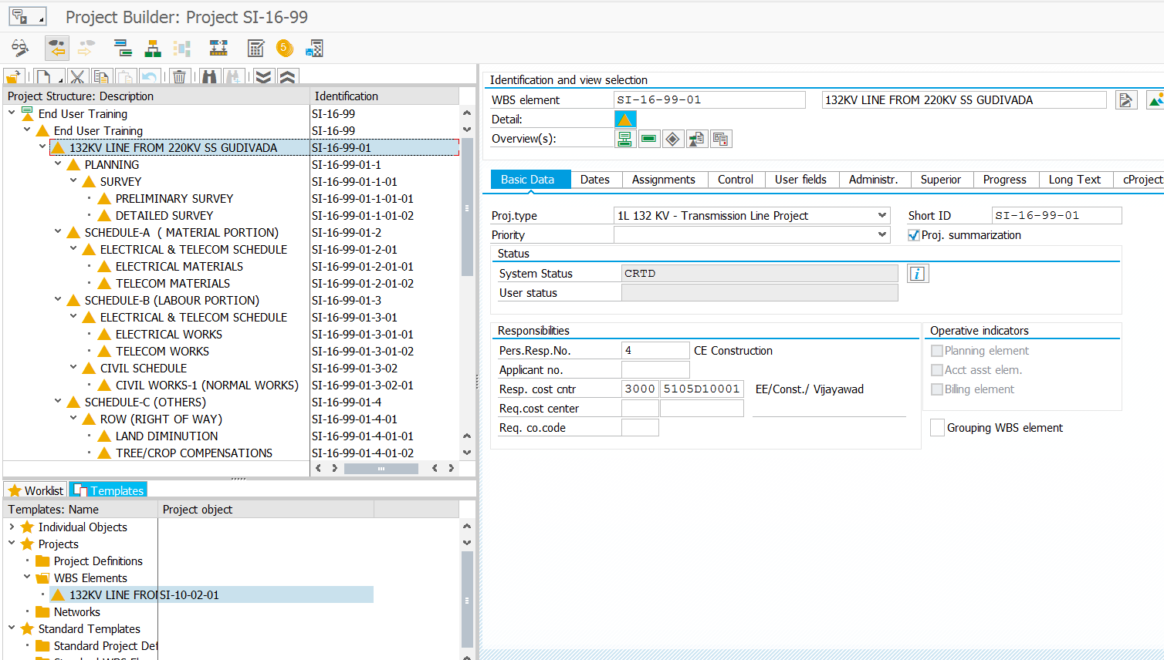
7.10
7.12
7.11
7.9

  - Select suitable Cost centre from F4 and then Save
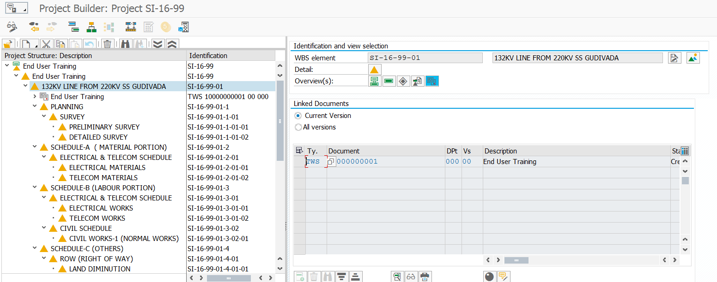
7.13
  - Select Document Overview to attach documents like tower schedule forms, designs, drawings or any common documents.

Easy Cost Planning
T Code CJ9ECP
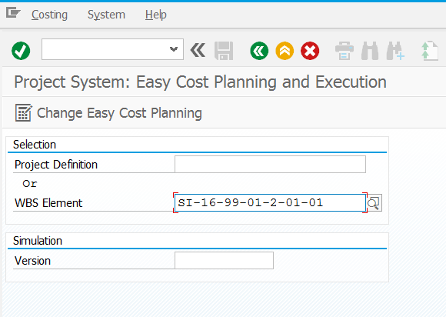
8.2
8.1
  - Enter your respective WBS element number to prepare the detailed estimate. For Ex:- Civil team will take only Civil WBS Element
  - Click on Change Easy Cost Planning
8.3
8.4
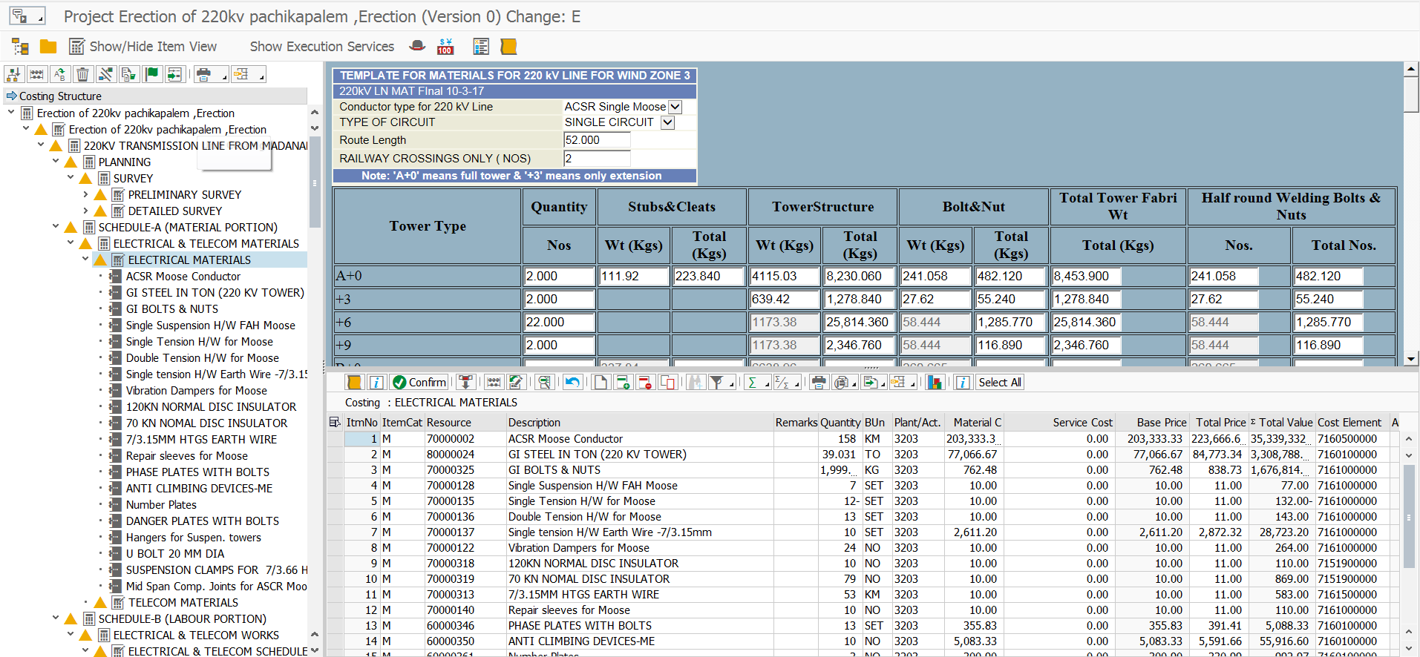
8.5
8.6

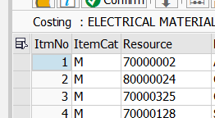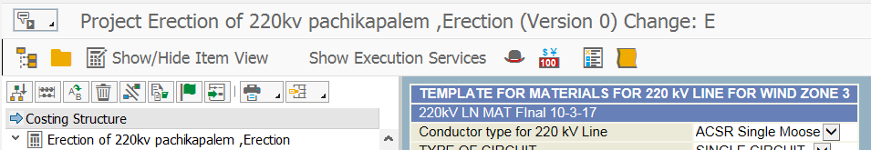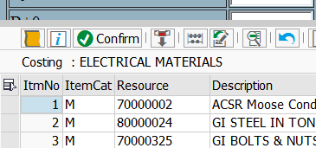
8.5
8.6
8.4

  - Enter all your inputs without pressing the “Enter” Button in Key board, after completion of all your inputs press the “Confirm” button in Template.
  - Click on icon(Show/Hide Item View) to see template derived Material codes or Service codes with Qtys and Prices. Can be input if you want to change any Qtys/Prices or any Line to be add.
  - After all changes, Select all icon
  - Click on “Confirm” button, if required press click 2 times on Confirm Button. Press back button and then Save button mandatorily, otherwise estimate will not be saved.

Workflow for Cost Estimates
T Code – CJ02
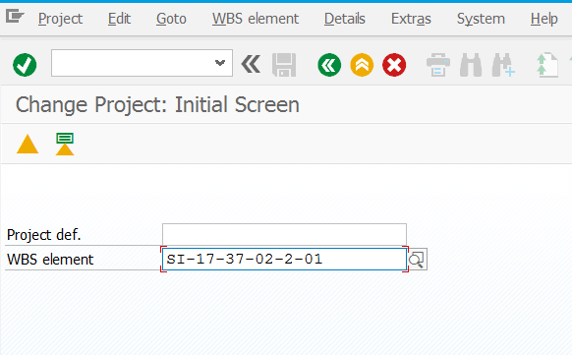
9.1

  - Enter your 4th Level WBS element because under 4th Level there will be no.of schedules like Schedule 1, 2, 3. Need to send all schedules at a time for approval, so selected 4th Level WBS. Enter 2nd Level for consolidation of all the estimates to send for approval –HO only
  - Select 4th Level WBS elementEDITstatusUser statussetSubmitted and then save. Work flow will be triggered and System derives attachment for this estimate.

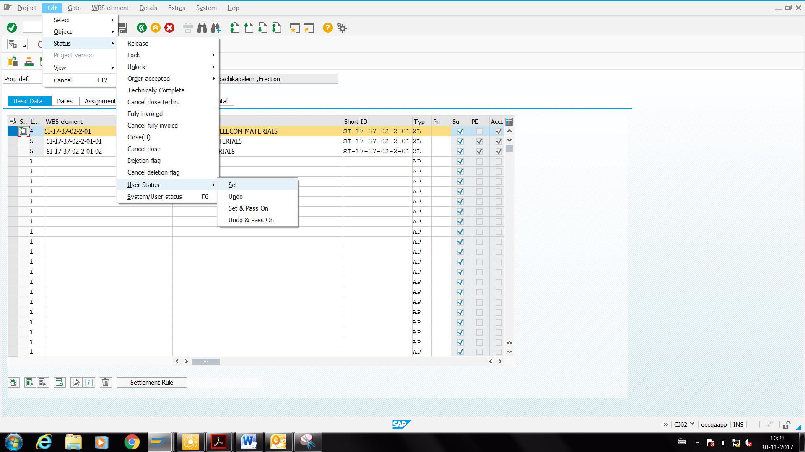
9.2

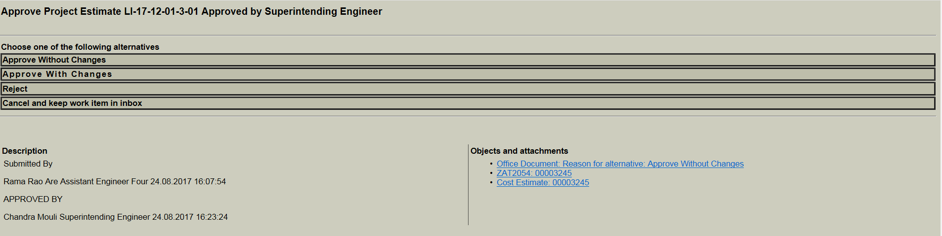
9.3
  - Click on attachment system provides you Excel sheet of your Estimate and PDF of Consolidated value.
  - After Submission of Estimate if anybody changes System records another attachment with their user id and date.

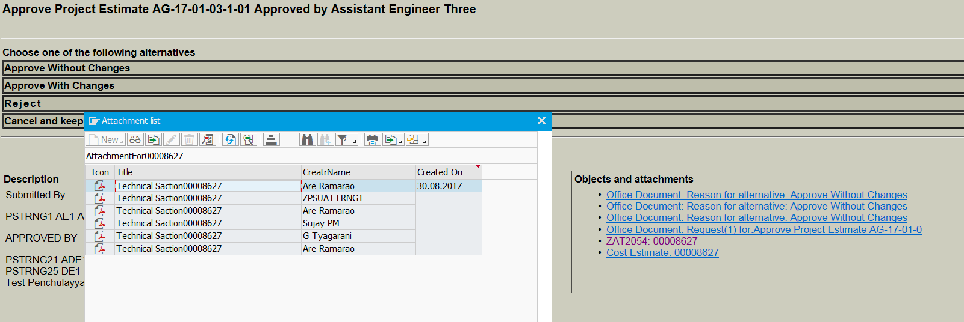
9.4
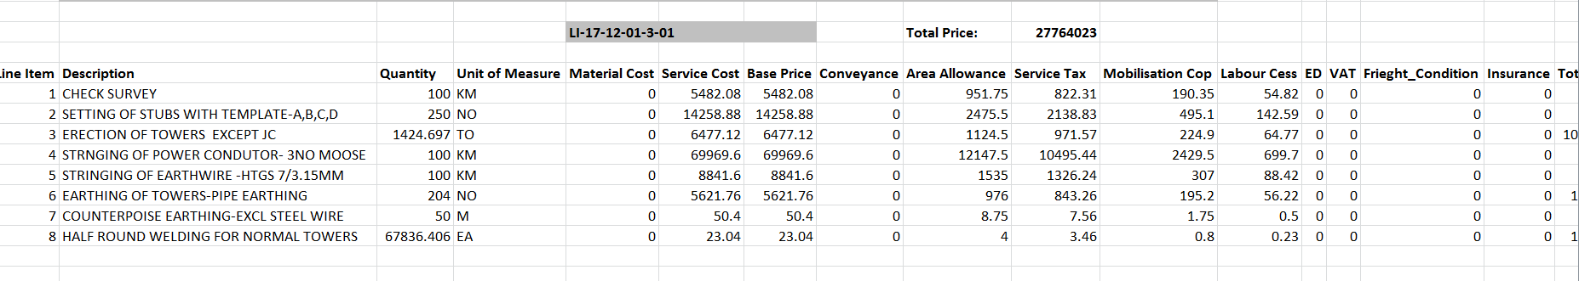
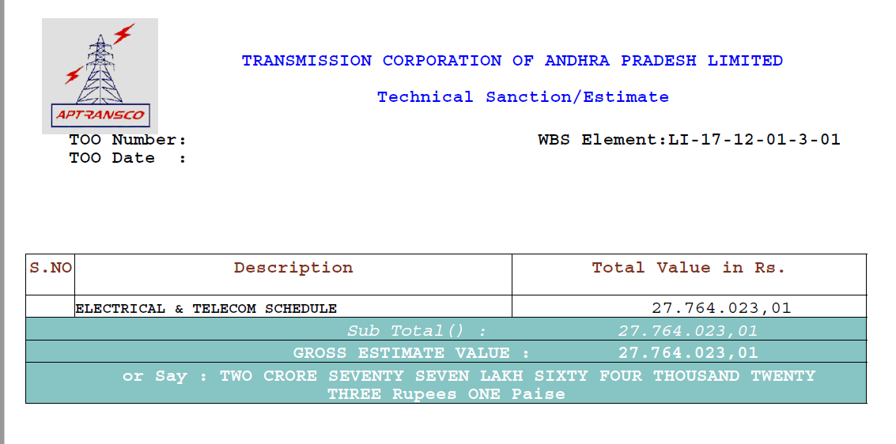

Create Purchase Requisition from Estimates

Create PR from Estimates
T Code CJ9ECP
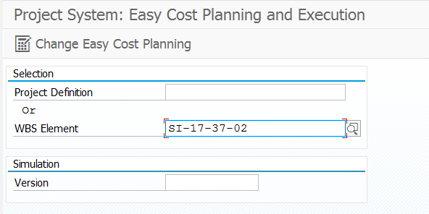
10.1
  - Enter 2nd Level WBS element of your project and select “ Change Easy Cost Planning”
  - Select WBS element on the left side of the panel ,For EX:- in case you want to create PR for Schedule A, including Electrical and Telecom Material, then select higher level of the Electrical and Telecom Material WBS

10.4
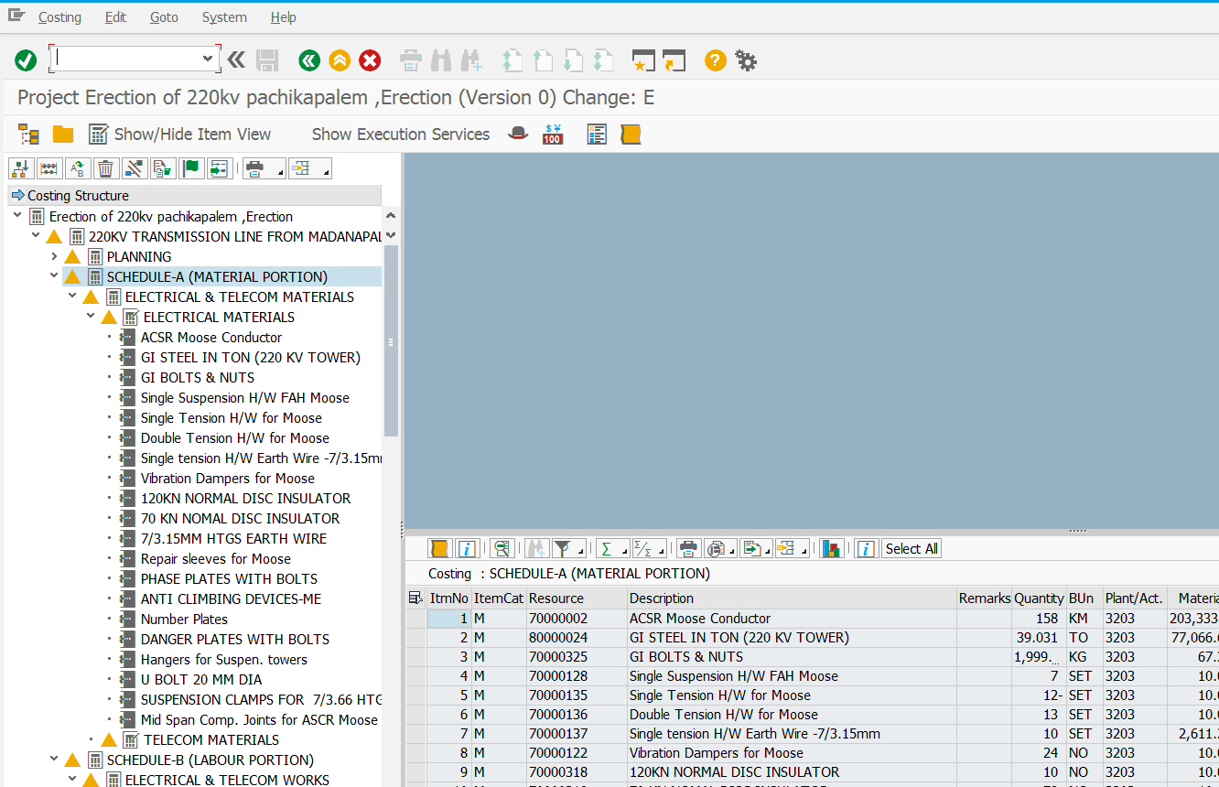
10.3
10.5
10.2

  - Click on Show/Hide Item View
  - Click on “GOto” on the Menu bar select Itemization breakdown on/off. Then you see all items of the schedule including Electrical and Telecom

  - Click on “Show Execution Services” icon for PR
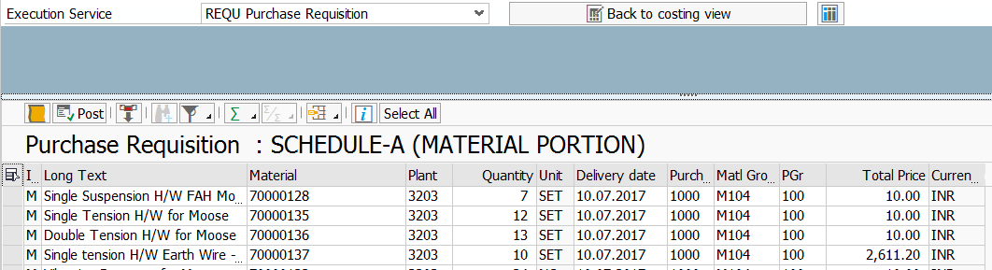
10.8
10.6
10.7
10.9

  - Select “REQU Purchase Requisition” from drop down box
    - Enter your related PGr-Purchasing Group and 1000 as Purchasing Organization and give the
delivery date a “future date”, through mass change(Click on “Select all” icon and change one of
the cell and click fast change button)
  - Click on “ Select all” icon if you want to create PR for all the items
  - Click on “POST” button then PR will be created and can be seen message in the bottom of the screen otherwise click on “LOG” button, available before to “POST” button.
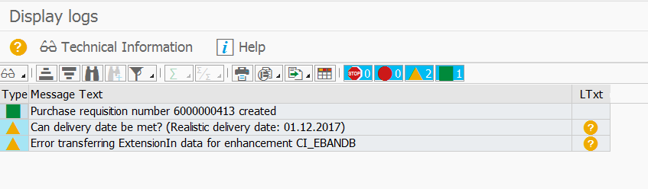
10.9

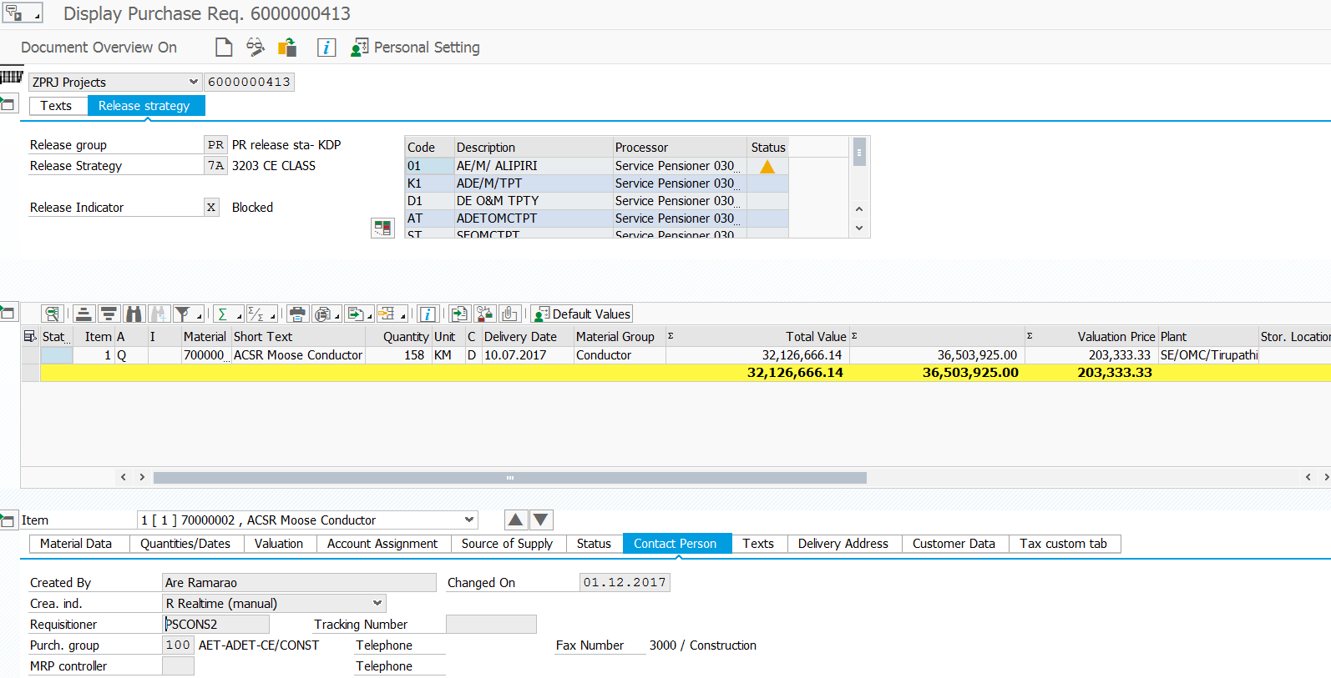

Create RFQ from PR
T Code – ME41
After finalization of the ECV and tendering analysis, RFQs can be created for each participant or finalized (L1) Vendor.
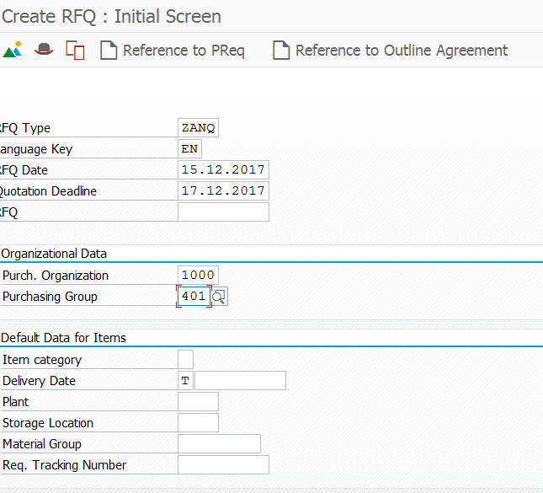
4
1
2
3
- Select “ZANQ” from search or Type
- Select Suitable dates
- Select suitable Purchasing group or Type

- Select Reference to PReq

Create ROW Purchase Requisition
T code – ZPS_PR_UPLOAD
11.1
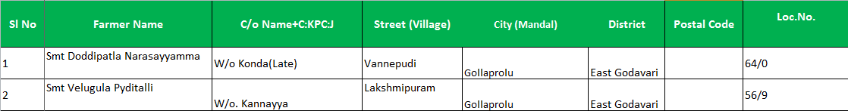
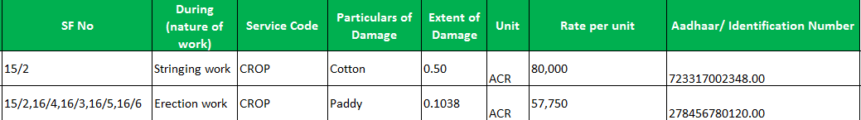
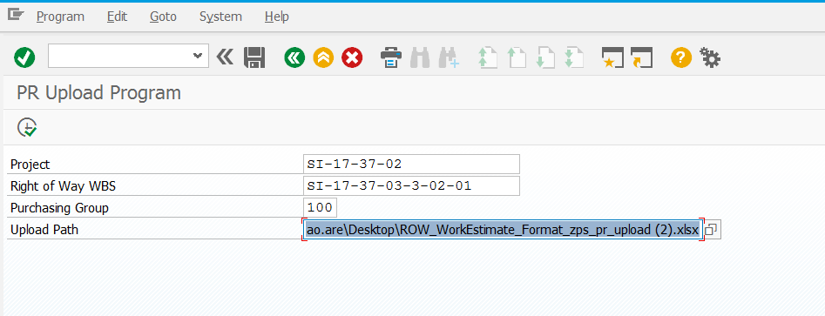
11.4
11.3
11.2
11.5
  - Maintain the Excel sheet in prescribed format as mentioned
  - Select your project from F4 or Type WBS Code
  - Select ROW WBS from F4
  - Select suitable purchasing group from F4 or Type
  - Select maintained data as mentioned in 11.1 and then click on Execute button

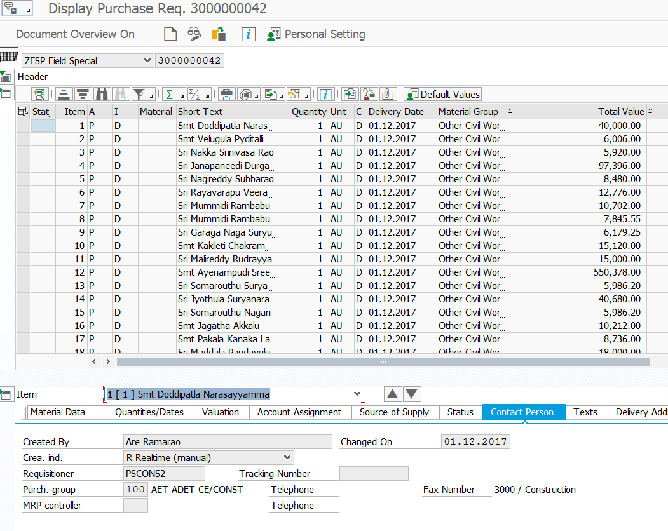

M-BOOK
Portal Link -- http://epprd.hec.aptransco.gov.in:50000/irj/portal

Create M-BOOK – Only for DEs
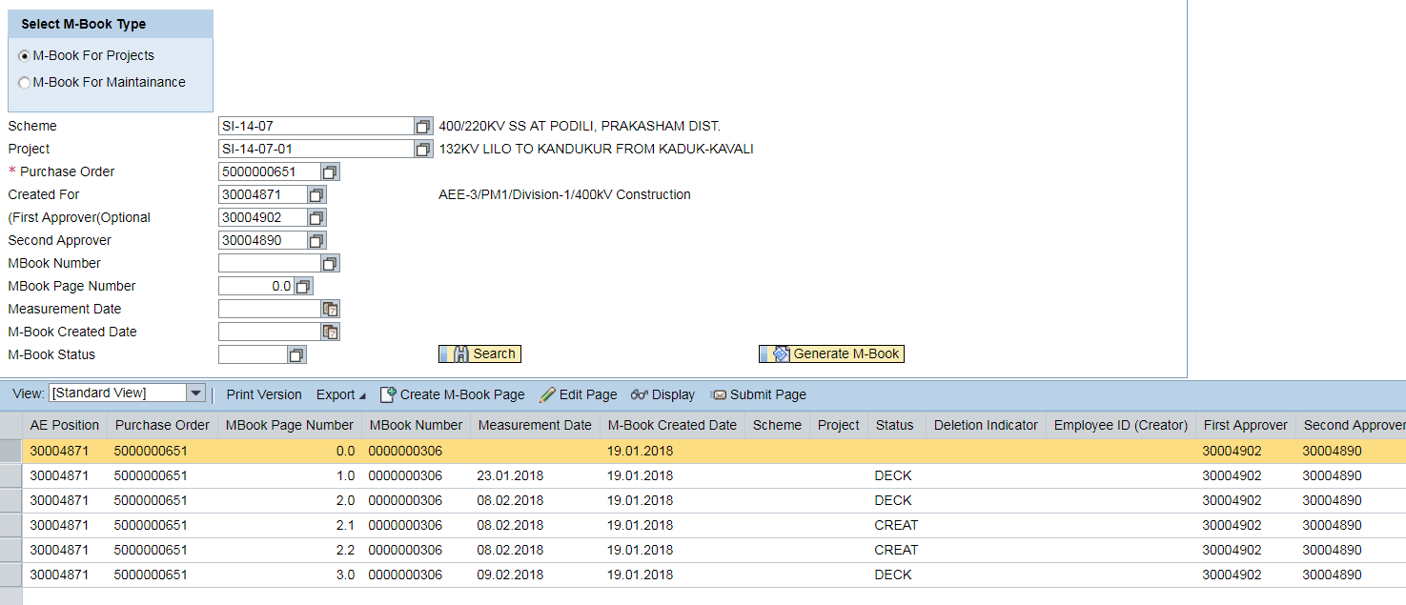
12.4
12.2
12.3
12.1
12.6
12.5
  - Select Scheme ID from F4 or Type
  - Select Suitable Project ID from F4 or Type
  - Select suitable PO number from F4 or Type
  - Select Suitable AE position ID from F4 or Type and First & Second approver
  - Select date from calendar from which date you need M-BOOK
  - Click on Generate M-BOOK button

Search for M-BOOK
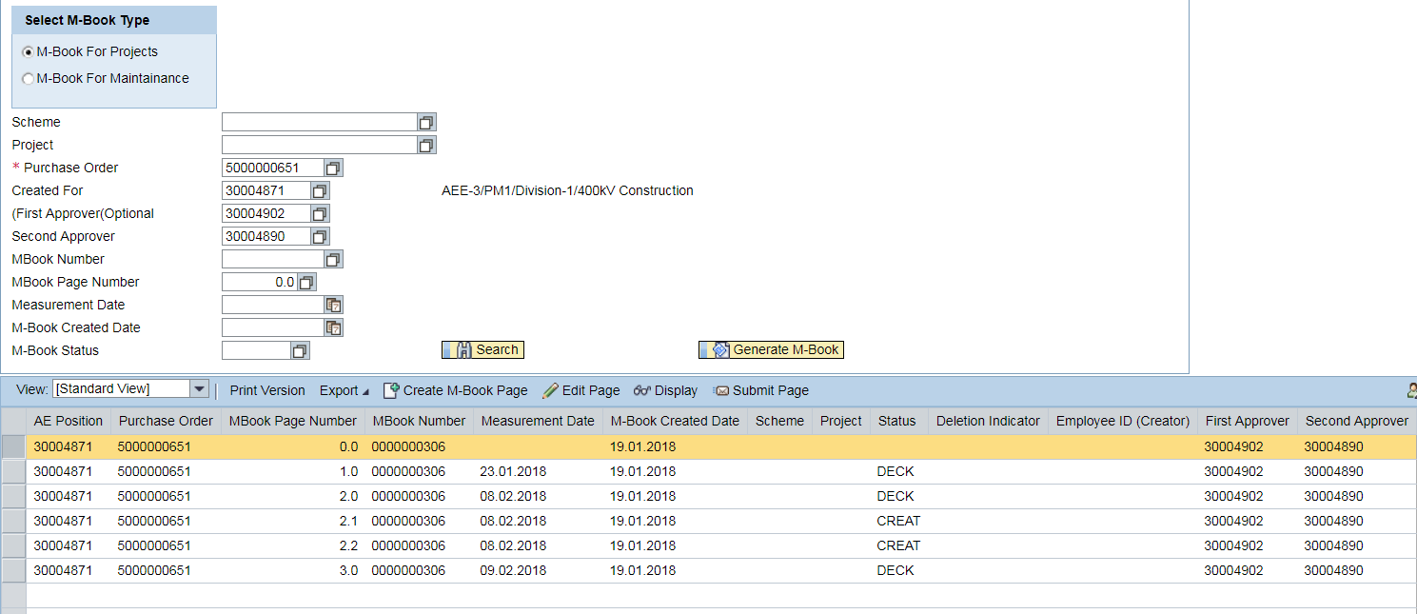
12.9
12.100
12.7
12.8

  - Type or Select your PO number from F4 and Position number which you want to search for
  - Click on Search Button for your M-BOOK which is DE created
  - Select M-BOOK number on the bottom side of the panel to create M-BOOK Page
  - Click on Create M-BOOK Page

Create and Submit M-BOOK Page
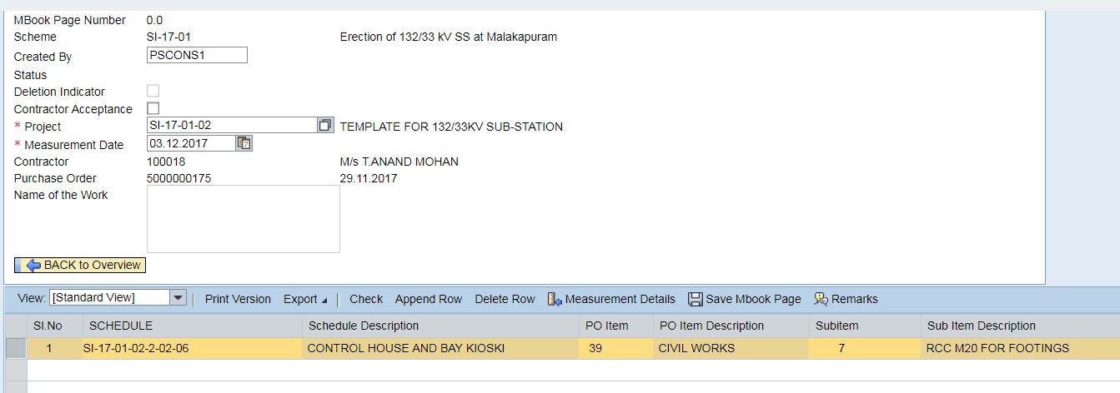
12.13
12.12
12.11
12.16
12.15
12.14

12.17
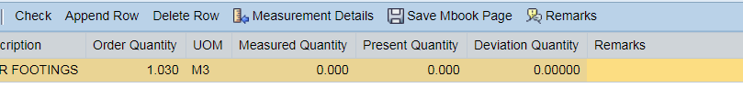
  - Select your Project from F4
  - Select Measurement date from Calendar, back date is also possible but make sure it should not be M-Book Creation date
  - Click on Append ROW
  - Select the schedule from F4
  - Select the item from F4 for which you want to create measurements
  - Select Sub item from F4
  - Click on Measurement Details to record Measurements.
  - Click on APPEND ROW
  - Write Description of your measurement, this is Mandatory*
  - Select Cut point/Main item
  - Select Location/item (for which you are doing measurements)
  - Based on your measurement type can be input your values in mentioned heads, system provides you the calculated value. For Ex:- PIT Excavation – LXBXD
  - Select Check box if that item has PERT penalty and how many months in next column
  - Click on Confirm Measurements button
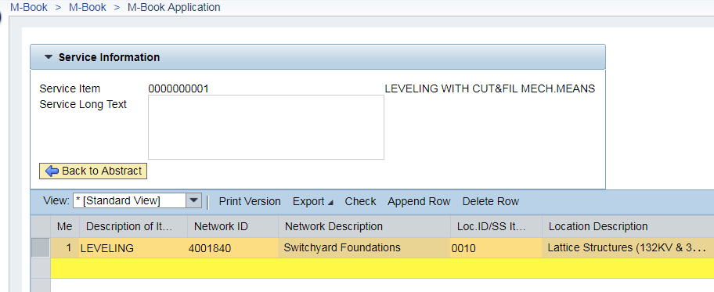
12.19
12.20
12.21
12.18
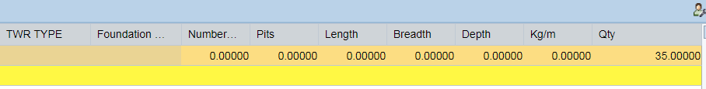
12.22

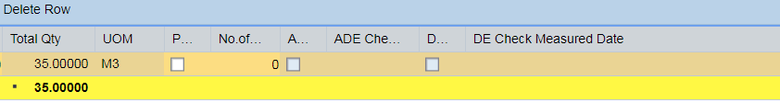
12.26
12.23
12.27

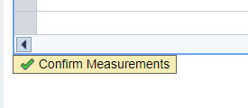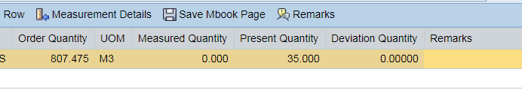
12.25
12.24

  - Check your Present Measured Qty and any Deviation Qty
  - Click on the Remarks button if you have any remarks to write
  - Click on Save MBOOK page button to save the page. Popup message with Page no.
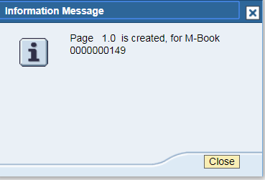
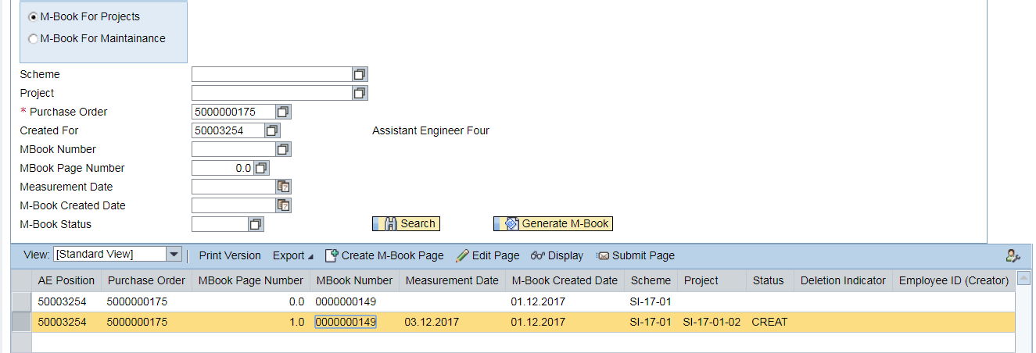
12.30
12.29
12.28

  - Click on Search button
  - Select your Page which you want to submit

- Before submitting the page, Run the transaction MIGO to record the Materials used for that particular services and Page.

Material account statement – 221Q
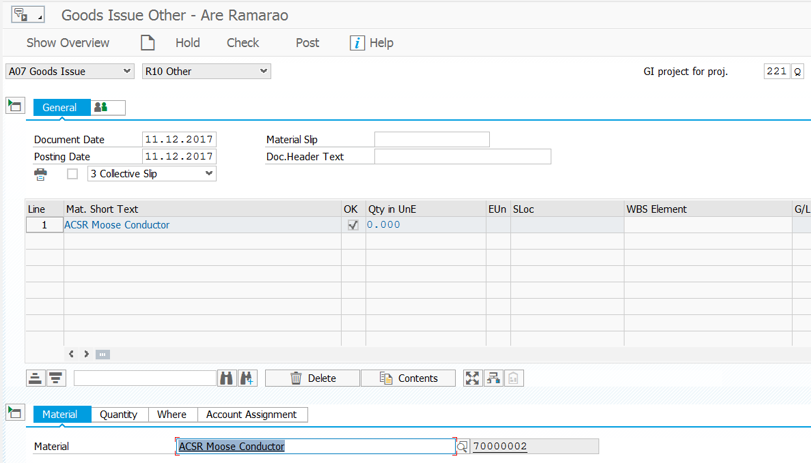
i
ii
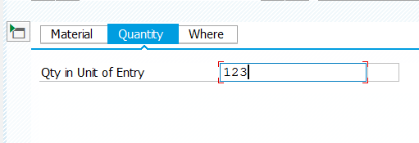
iii

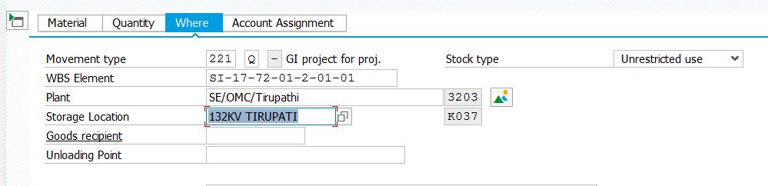
iv

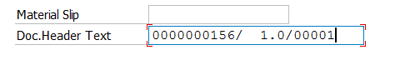
V
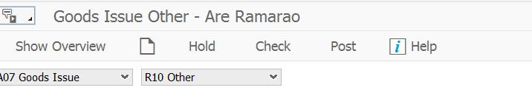
Vi
- Select “Goods Issue” and “Other” from the Drop down box.
- Select or Type material code which consumed for Service
- Enter Qty and Press Enter button
- Select your material WBS Element (to find out Material WBS Element go to POmaterial item ViewPurchase Order Historyclick on the 105 Document….Generally, Storage location is one for one Project), Plant and Storage Location.
- Click on “Doc.Header Text” field and click “F4” on Keyboard, select your M-Book Page Number, then Click OK button in the bottom of the screen.

- Click “Check” and make sure you don’t have any errors and then “POST”

  - Click on Submit page button and Write the Remarks.
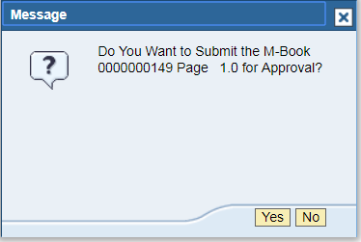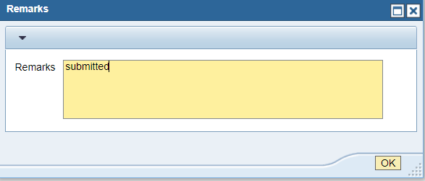

Approve or Check Measure M-BOOK Page – Only for ADEs, Des

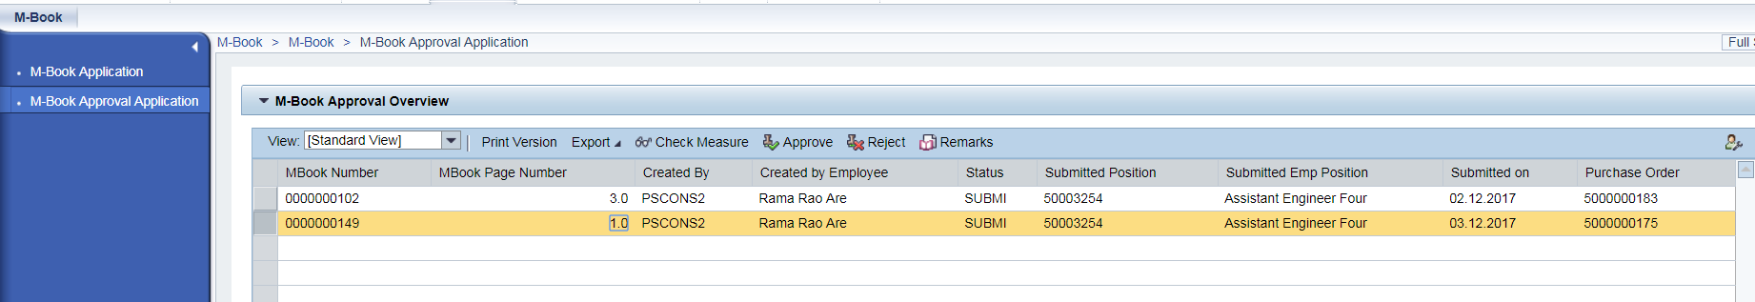
12.37
12.36
12.32
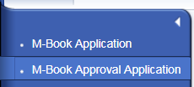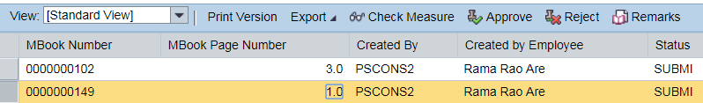
12.31
  - Select M-BOOK Approval Application, can be seen Right side panel how many pages are pending with you
  - Select Check Measure button if you want to check Measure
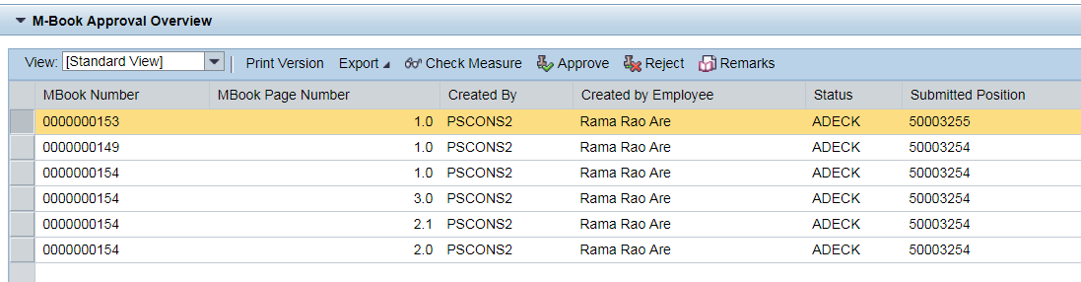
12.34
12.33
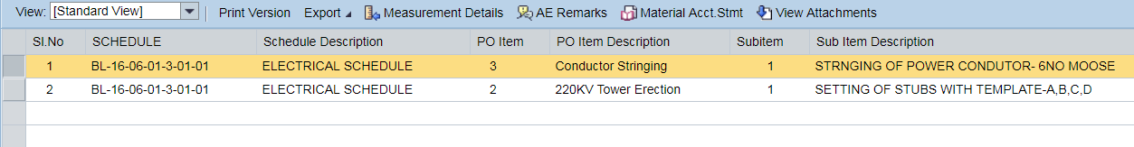
12.35
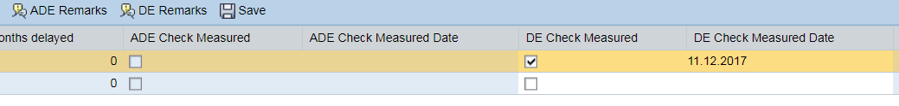
  - Select Page and Click on Check Measure
  - Select item and click on “Measurement Details” and click on “View attachments” if required
  - Click Check Box and Mention the date Mandatory* , for any Remarks click on ADE/DE Remarks
  - Click on Approve button directly if no need of Check Measure
  - Click on Reject button and click on Remarks if needed

Service Entry Sheet
Portal Link -- http://epprd.hec.aptransco.gov.in:50000/irj/portal

Search Service Entry Sheet

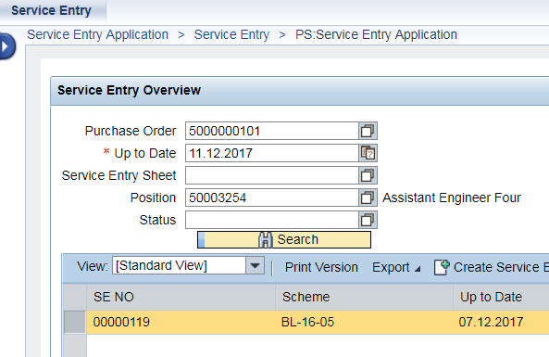
13.3
13.2
13.1
  - Type suitable service Purchase Order or from F4
  - Select Up to Date from F4 or Type.
  - Click on Search button; get all the SE numbers as on that date with Status.

- Also can be search with SES number, Position ID and Status

Create Service Entry Sheet

- Generally, this action will be done by Electrical AE, does not mean that others AEs cannot be done. Any AE can be creating which is having M-BOOK under this Purchase Order.
- To create Service Entry Sheet, Perform the actions from 13.1 to 13.12

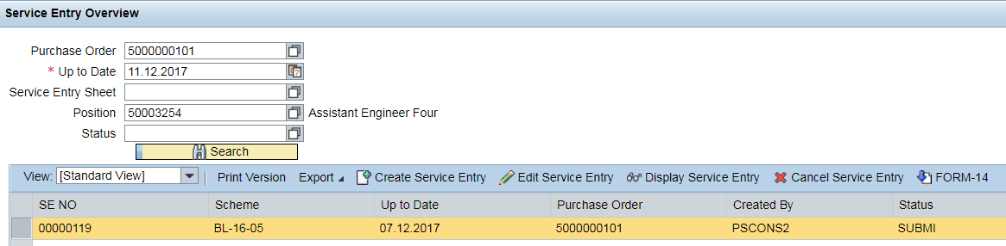
13.5
13.4
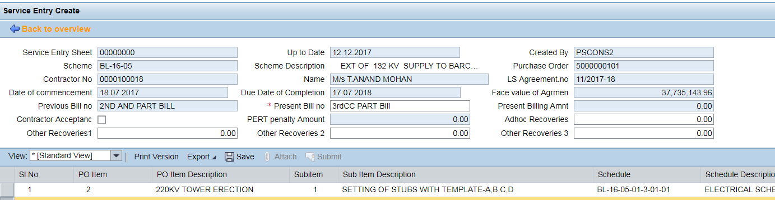
13.6
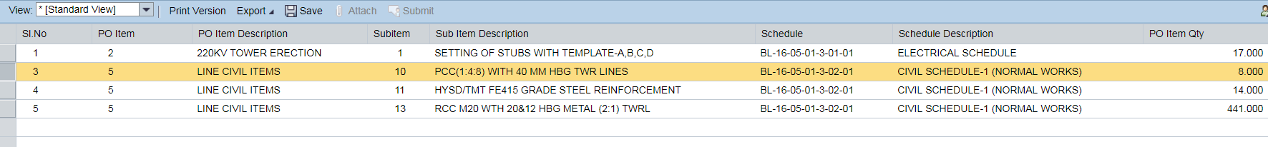
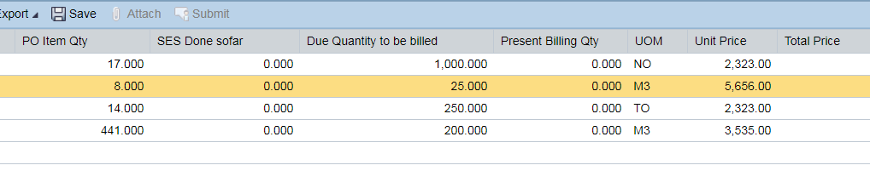
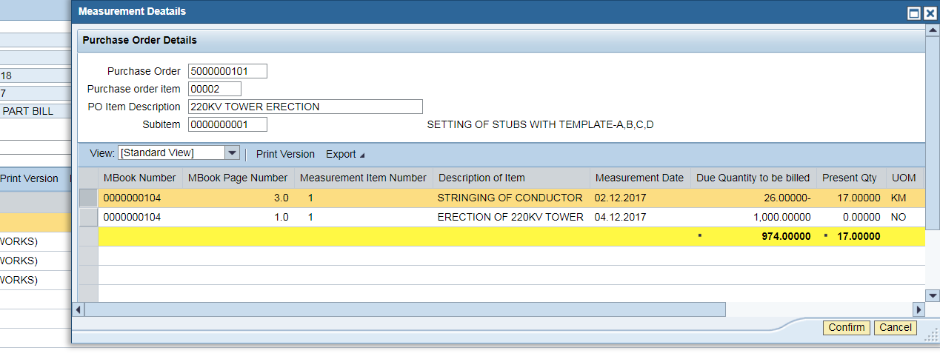
13.7

  - Click on “ Create Service Entry sheet”
  - Write the description of “Present Bill No” Mandatory*
  - Click on each line and see that details are accurate
  - Click on “Confirm” button for line item
  - Click on “SAVE” button, Popup appears with SES number
  - Select new SES number line
  - Click on “Edit Service Entry”
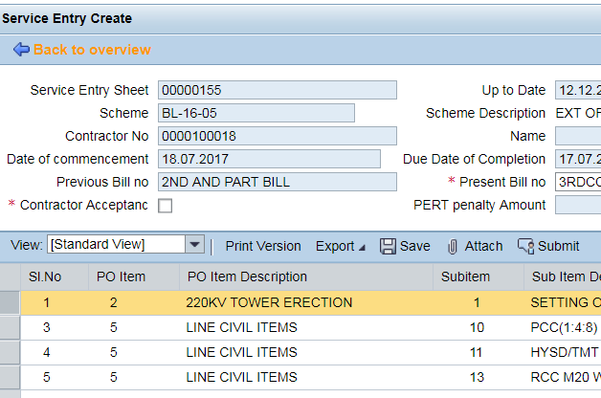
13.8
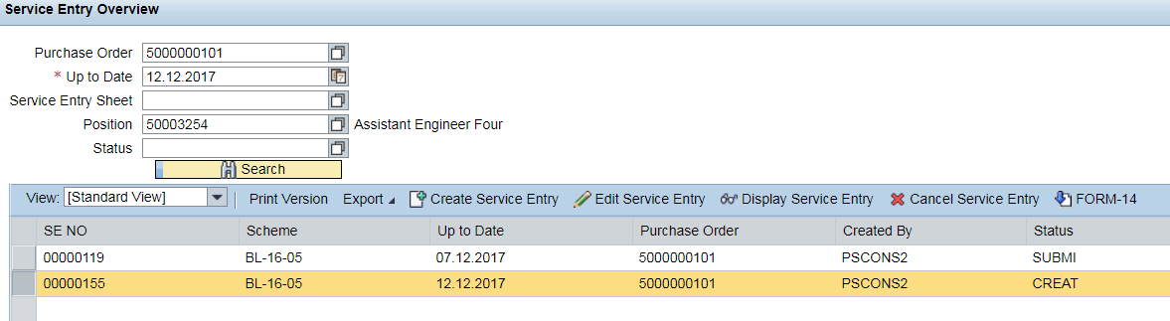
13.9
13.10
13.12
13.11

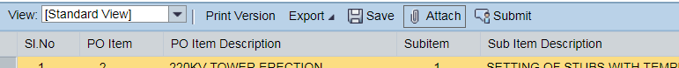

  - Click on “Attach” icon to attach required files
Before submitting the Services Entry sheet, mandatorily attach the below files.
- Seignorage Report
- Contractor Acceptance Report- FORM-14
- Penalties Report
- Material Account statement
- Others if any

Create Seignorage Report
T- Code -- ZPS_SEIGN_CHRG
- Type or Search SES number
- Click on Execute
- Type “LP01”
- Click on “Print preview”
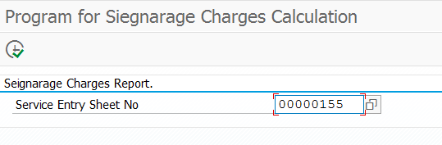
ii
i

iii
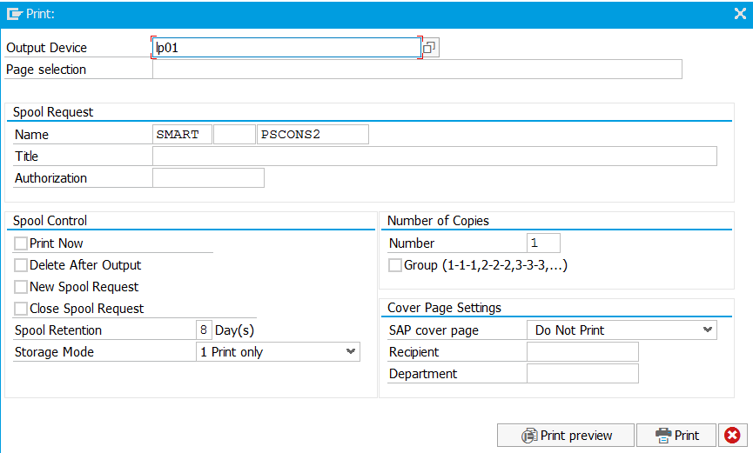
iv

- Click “Go to” on menu barPDF view

V
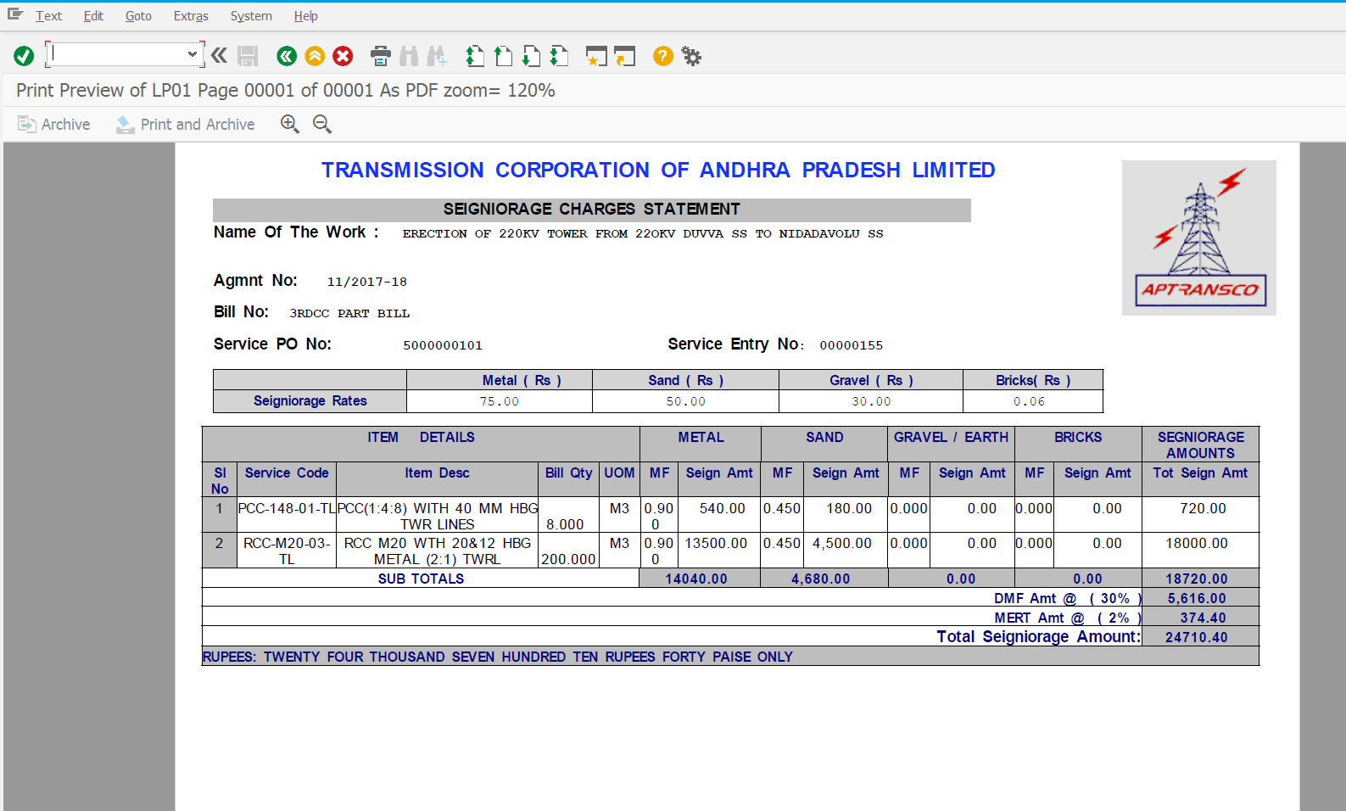

Contractor Acceptance for SES – FORM14

Get the contractor signatures on Workbill/FORM-14 and attach to SES as mentioned above before submitting.
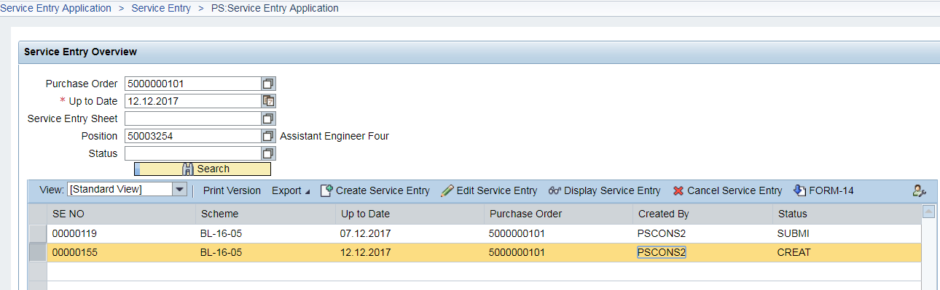
i
ii

- Select suitable SES
- Click on “FORM-14” and save in Desktop to attach in SES
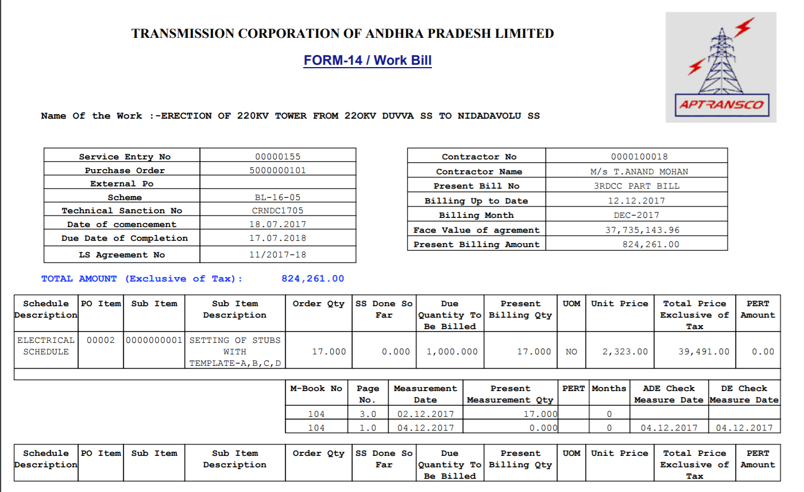

Penalties, Recoveries Report
T-Code – ZMM_PC_REP
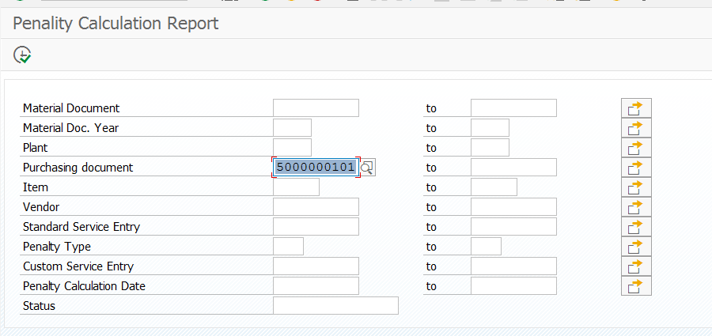
ii
i

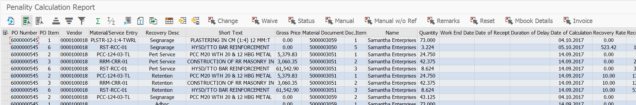
iii
iv
v
vi
vii
viii
ix
x
Xi

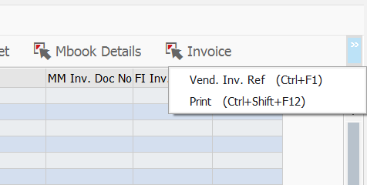
xiii
xii
- Type or Search suitable Purchase Order to calculate all Penalties and Recoveries and then click on Execute button
- Type Material Document (105) for Material related
- Select the Line and Click on “Change” button, if you want to correct the Penalty Value
- Select the Line and Click on “Waive” button, if Waiver is approved
- Select the Line and Click on “Status” button for Line status
- Select the Line and Click on “Manual” button to create Manual entry with any reference of the line item

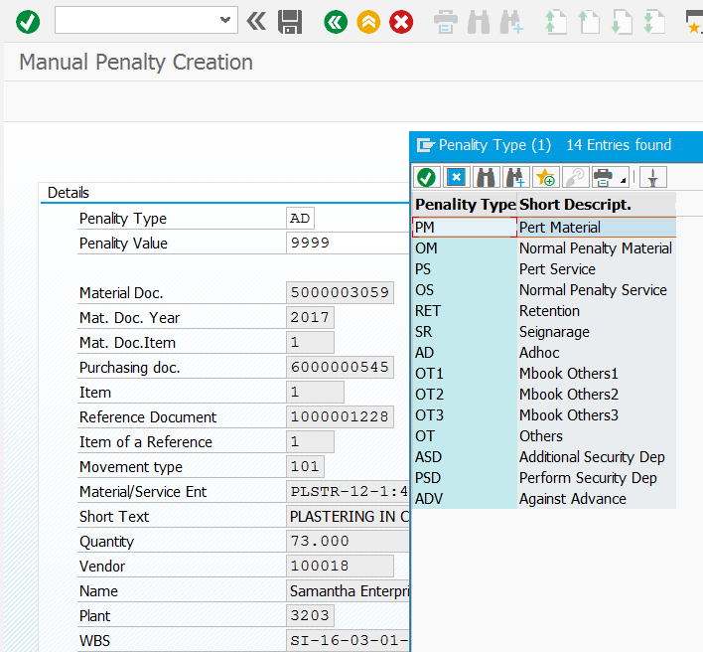
c
b
a
- Type or Select from F4
- Enter your Penalty amount and click on “SAVE” button
- Click on Back button
- Click on Refresh button

d
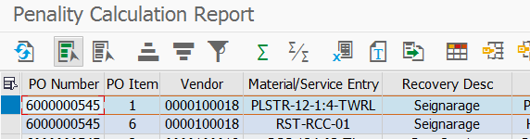
- Select the Line and Click on “Manual w/o reference” button to create Manual entry without any reference of the line item

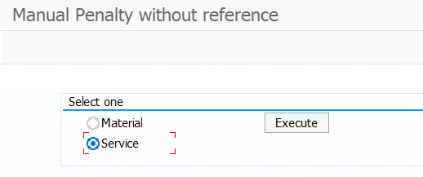
a

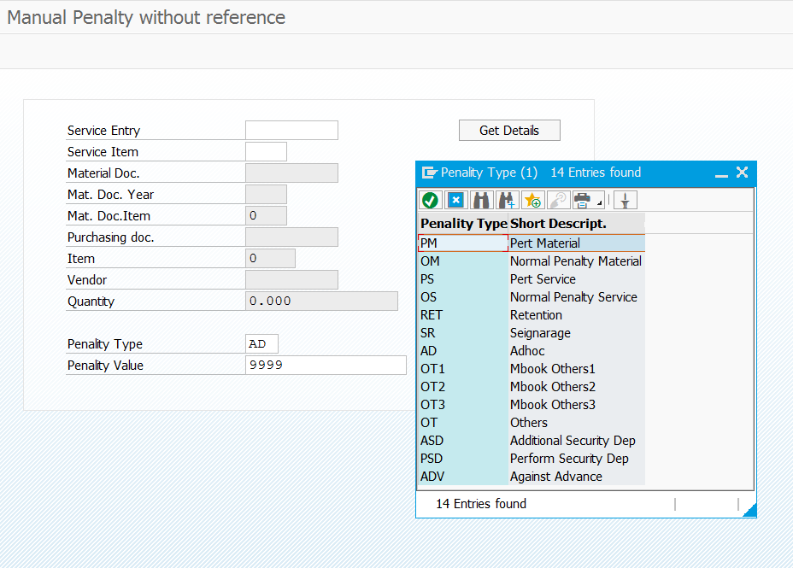
b,c
- Select suitable radio button and then click on Execute button
- Select suitable Penalty type or search from F4
- Enter penalty amount and click on “SAVE” button and Back button.

- Select the Line and Click on “Remarks” button
- Select all and click on “Reset” button if max CAP of the penalty percentage changed in the PO
- Select the Line and click on “M-BOOK details” if needs the details.
- Select the Line and click on the “Invoice” button to update invoice document number, this will be done by Finance

- Select the Line and click on “ Ven.Inv.Ref.No” , can be updated multiple lines at a time. Select lines and click on “Ven.Inv.Ref.No”.
- Click on “Print” button and this print will refer same Ven.Inv.Ref.Number
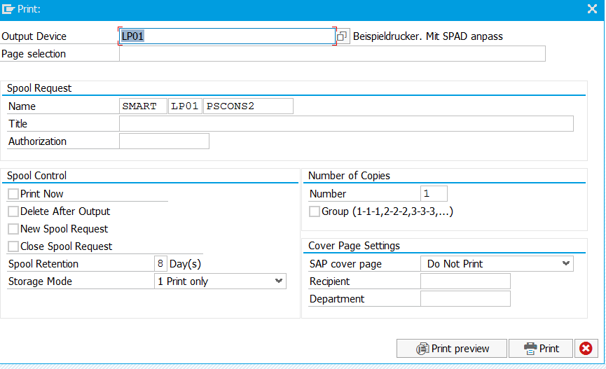
b
a

- Type “LP01”
- Click on “Print Preview” and then Click on “EDIT” in menu barPDF preview

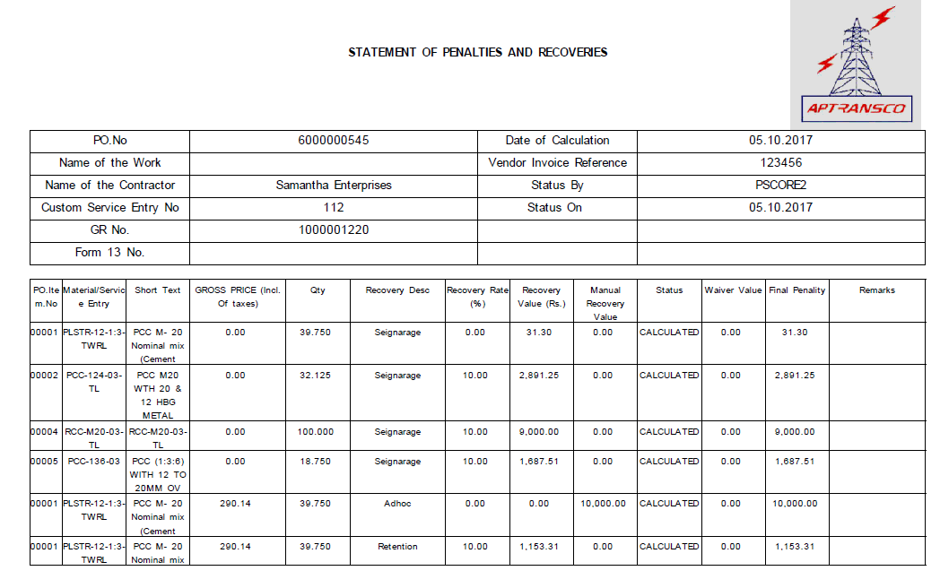

Service Entry wise Material Account Statement
T-Code -- ZPS_SEMATACNT
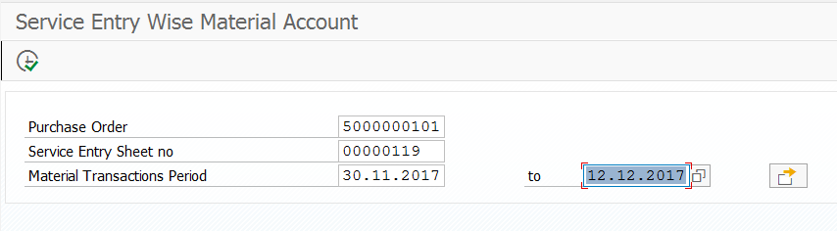
c
b
a

- Type or Search suitable purchase order number
- Type or Search suitable Service entry sheet number
- Select the periods of statement required
- Click on icon arrow mark and Select Spread sheet to save the file in your desktop.

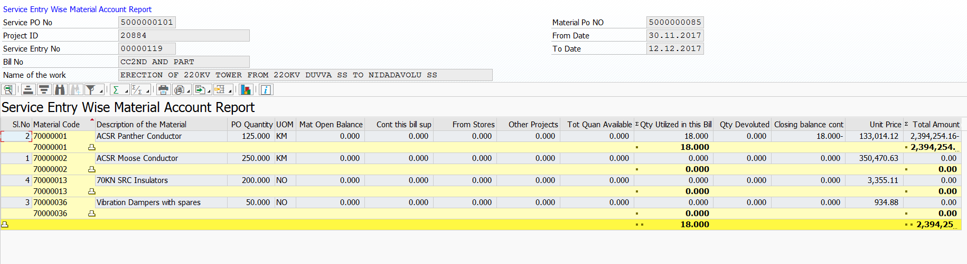
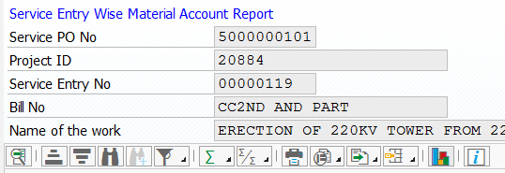
d

  - Click on “Submit” button after attaching all required documents.
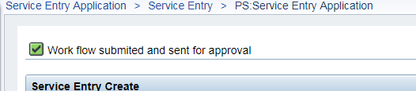

Workflow for Service Entry Sheet only for ADEs and DEs.

After entering in to the portal, click on Self services.
- Click on suitable Service Entry Sheet number
- Click “Approve” or “Reject” button
- Click on Download attachments, if wants to see what and all AE attached.

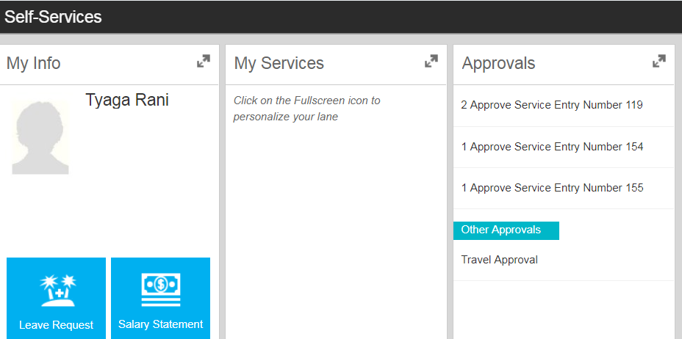
a
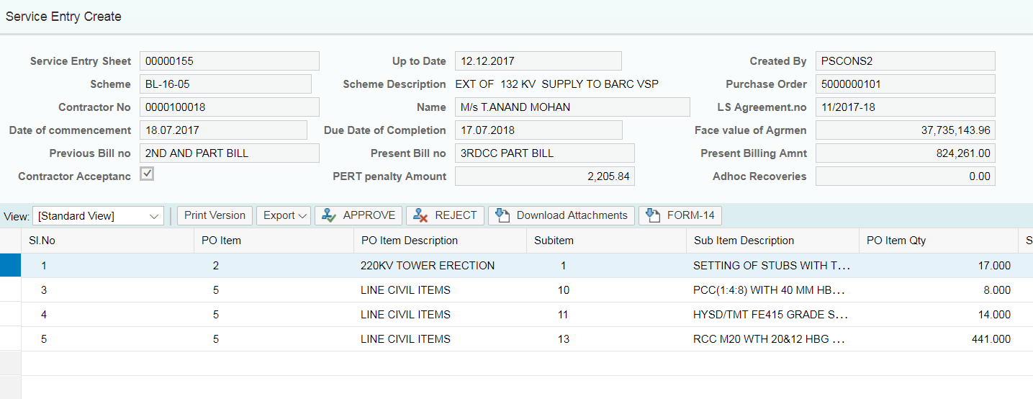
c
b

Tower Schedule form Upload – AETs, ADETs and DETs
T-Code -- ZPS_TWRSCH_UPLOAD
Maintain the Excel sheet exactly as mentioned below
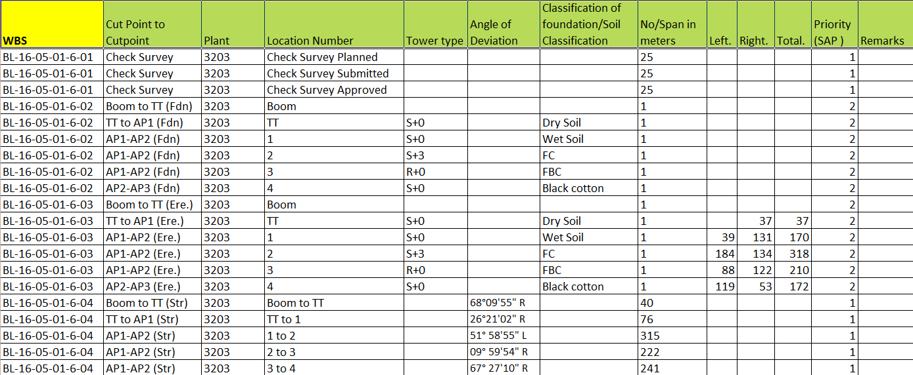
a

- Priority Column is very essential for Physical Progress
- 1represents Survey related activities or activity to be highlighted in physical progress and quantity to be measured (for Ex:- qty – 25 and completed 15)
- 2represent Foundation activities or Structure yard foundations (activities to be consolidated show as Foundations in Physical progress. For Ex:- locations are 40,it shows Foundations-40)
- 3represent Erection activities (activities to be consolidated show as a Erections in Physical progress. For Ex:- locations are 40,it shows Erections-40)
- 4represents Stringing activities or activity to be highlighted in physical progress and quantity to be measured (for Ex:- qty – 25 and completed 15)

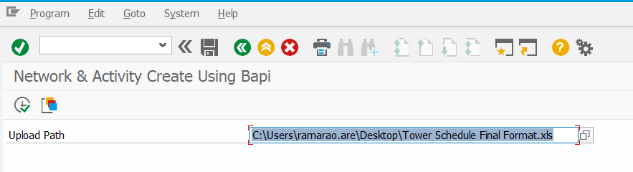
c
b
- Select your upload file
- Click on Execute button
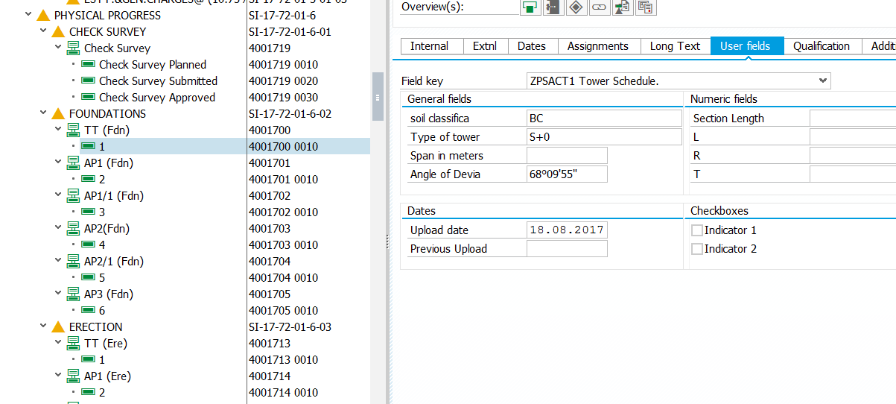
- While uploading the Tower schedule Form if you don’t get Civil data, later add manually, for that go to CJ20N select particular activity and click on User Fields. Scan and attach to activity of original documents

Physical Progress – AEs, ADEs

Physical Progress reports can be seen in BI and BO reports, to get these reports, the main base is activity confirmation.
T- Code – CN25
15.2
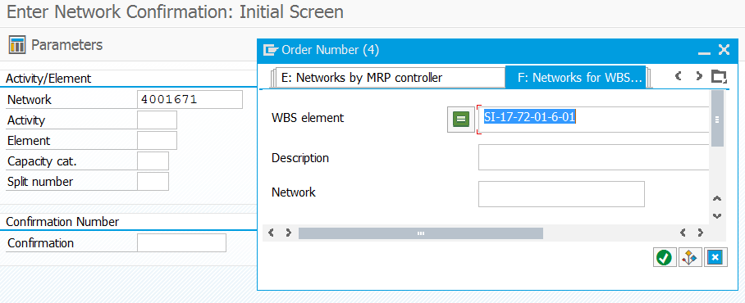
15.3
15.1
  - Select or Type suitable network number
  - Select the Networks for WBS Element tab
  - Select the suitable network by giving suitable WBS element and Press Enter on the keyboard

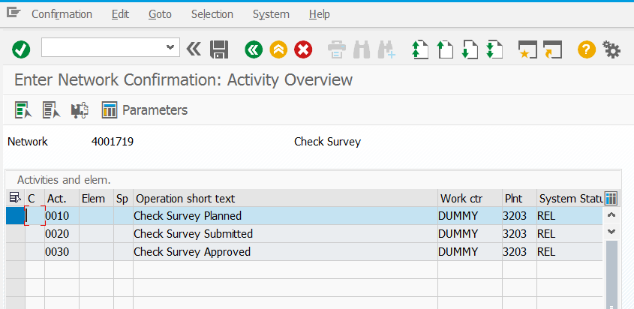
15.5
15.4

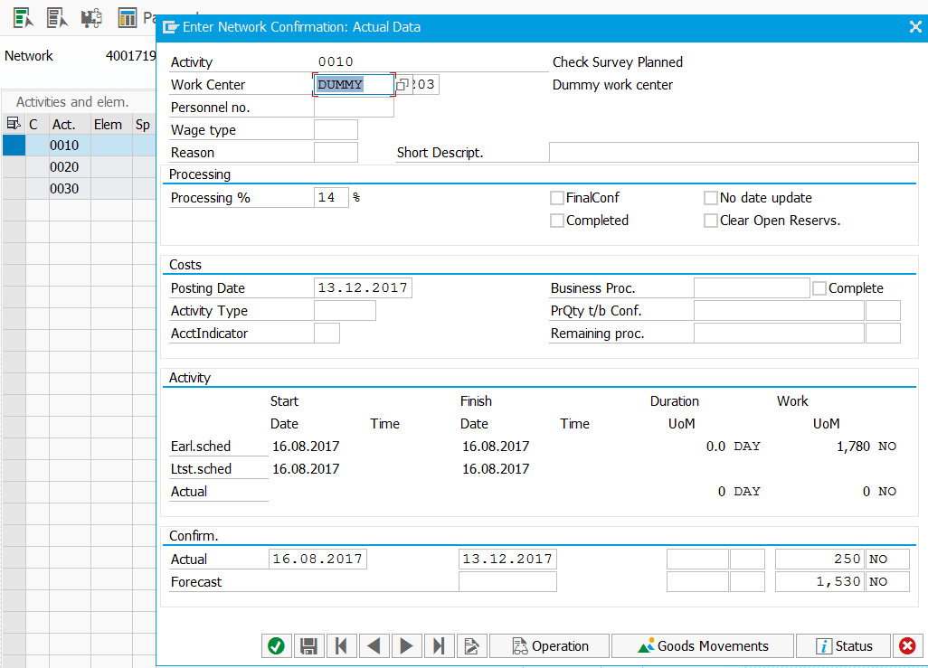
15.8
15.7
15.6
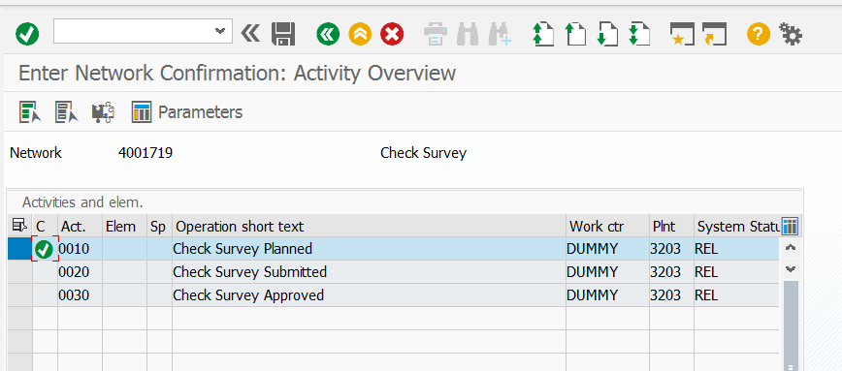
15.8
  - Select activity
  - Click on Actual data icon
  - Type how much % work completed, automatically system converts in terms of Quantity see in 15.7 or Type Quantity automatically system derives %
  - Same as 15.6

  - Click on “SAVE” button

Reports & T-Codes

