PROJECT SYSTYEM TRAINING MANUAL

INDEX
- Goods receipt
- Material indent for drawl of material
- Creation of allotment order based on indent
- Devolutions
- Transfer of material from project to project ( Within in the circle & Circle to Circle )

Goods receipt & cancellations
How to receipt material against inbound delivery (103 movement)
The Procedure for receipt of goods against an Inbound delivery no. is as follows
- Before receipt of material check the following in purchase order
- Material description in PO against the actual Invoice description
- Material UOM, quantity, rate and taxes
- Funding agency
- Contractor name, address in PO and invoice address
- The above data can also be checked through a report ZPS_DI_CHECK.
- If any of the above data found to be incorrect inform to the concerned PO placing authority and get correction of data
- If above data is ok, then get the inbound delivery no against the material to be received as follows
- Go to ME23N and enter the purchase order no.
- Go to confirmation tab in item details and note down the inbound delivery no.
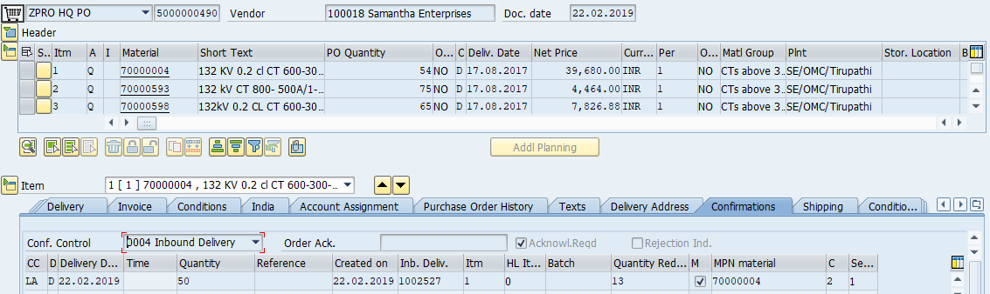

- Go to MIGO and enter/select the following data
Goods receipt
Inbound delivery
Inbound delivery no.
Movement type 103
Enter invoice no./delivery challan no. in Delivery note field.
Document date should be invoice date/Delivery challan date
Posting date is date of receipt of material at site, however system will allow only current month and previous month dates only

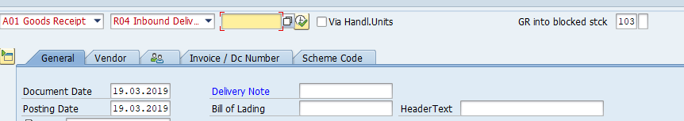
- After entering data execute (press F8 or Clock icon)
- Check the following fields for correctness of data
TAB FIELD
Material Tab Description of item
Quantity tab 1. Quantity in delivery note ( qty in DC
/Invoice furnished by the contactor)
2. Quantity in unit of entry: Actual
Quantity received at site against the
Invoice
- If data is correct then check the item ok box in where tab
- Go to “Scheme Code” tab, check Scheme ID and funding agency details. If not correct, inform the PO placing authority (HQ ADE) for correcting the same.
- If all the above data is correct , then press check button in the header and if it is ok then press post button

- How to cancel the material received up to 103 movement
- If material received by 103 movement is found to be wrong then you can cancel the transaction through document cancellation as follows
- Go to purchase order in me23n
- Go to Purchas order history tab in item details and note down the document no. of 103 transaction
- Go to MIGO and select the following:
Cancellation
Material Document
And enter the document no of 103
- If 103 document contains multiple material you can cancel any selected material by selecting the check box in item ok in quantity tab. If you want cancel all the materials then select the item ok check box for all materials.
- Further step after 103 movement for receipt of material
- After material received in 103 material is to be check measured by ADE/DE as per the value of the material
- Check measurement will be done in inspection lot which will be automatically created after 103 movement
- To access the inspection lot, go to QA32 and enter the following data 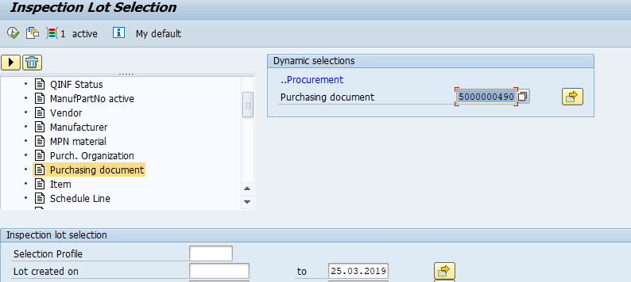

- Click the dynamic selection icon and go to purchasing and purchasing document and double click it and enter the PO no.
- Delete the from date in lot created field
- In the list settings select the radio button for
Select only inspection lots without usage decision
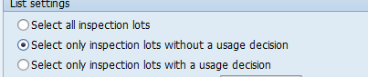
- Then execute (Press F8 or press clock icon)
- All the inspection lots without Usage decision (Means material still to be check measured and taken in to the stock) will be displayed
- Select the required inspection lot and select the results icon
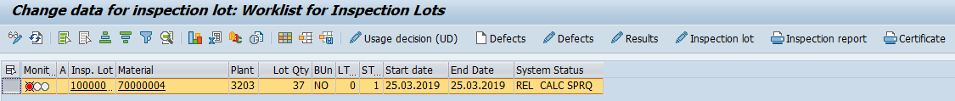
- Enter the check measure from date and to date in the icon look like calendar in general tab and double click results field and select the code from list of values and also fill the field Nonconf with 0 if total qty accepted if part qty accepted then enter the rejected qty in Nonconf field
- Then press Save icon and then ok
- After DE’s Check measure material is to be taken into stock by AE

- To select the inspection lot follow the steps mentioned in item.no.3 in the above step
- The lot status should be like this “INSP RREC SPRQ”
- Select Usage decision icon and select suitable “ud” code from list of values
- Then select the “inspection lot to stock” tab and select the suitable storage location in SLOC field from list of values and then save
- How to cancel the material after taken in to stock (105 movement)
- You can do 122 movement following the same procedure as mentioned in step I, only change is you have to select 122 movement instead of 103 movement.
- Go to MIGO and select the following:
Goods Receipt, Purchase Order/Inbound Delivery,122 movement type. Select the material and Qty for which you want to cancel 105.
In “where “Give Storage Location,change ‘Stock type’ to ‘Unrestricted’ and Reason for Movement to 01/02.
Check ‘’Item Ok”, Enter Delivery Note , Check and Save
RAISING INDENT FOR DRAWEL OF MATERIAL FROM TLC STORES
- Identify the SAP part number.
- Check the stock availability in stores
Tcode: “ZMM_STOCK”
- Raising indent is nothing but creation of PR (Purchase requisition)
- To create indent, go to “ME51N”
- Select document type “ZSTO” (Material Indent)
- In the Account assignment column (Beside “Item” Column) select “Q”
- In the Item Category column Select “U” i.e., Stock transfer
- Enter the material part no. in Material column
- Enter quantity in “Quantity” Column
- In the plant column enter Business area
(For Ex: Kadapa “5104”)
- Enter Storage location of EE/Const. in the “Stor. Loc.” Column
- In the “Splt” column enter Stores plant no.
- Check and save the document and note down the Purchase Requisition no.
CREATION OF ALLOTMENT ORDER BASED ON INDENT (PURCAHSE REQUISITION)
- Go to “ME21N”
- Select document type as “STO ALLOTMENT ORDER”
- Allotment order is created based on the purchase requisition i.e material indent. For this we have to select the relevant PR and to be adopted for the allotment order.
- Check “document Overview “(this can be find left side to “create” icon) status, if it is “ON” then click it.
- Go to “selection Variant” icon on left side and select purchase requisition
- Enter purchase requisition no. and click “clock icon” i.e Execution
- Left side purchase requisition will be displayed. If it in multiple lines then select all lines and click adopt icon
- Check material and quantity and save the document and number will be generated and note down the no. and communicate the no to person raised the indent.

HOW TO CHECK WEATHER ALLOTMENT IS GIVEN FOR INDENT RAISED
- Go to “ME53N” and enter the purchase requisition number
- Go to Status tab and if allotment order is given then we can get purchase order no.

HOW TO SPLIT THE OUTBOUND DELIVERY QUANTITY
Material will be drawn from stores based on the outbound delivery number in the allotment order. If partial quantity is to be drawn against the allotted quantity the out bound delivery is to be split in to two or three based on requirement for this following procedure is to be followed.
- Enter T code “VLSP”
- Enter the Out Bound Delivery Number
- Select profile “003” i.e., “Delivery Split – LE components” in the split profile field
- Then Execute (press Clock icon)
- In the split quantity enter quantity to be drawn in first phase
- Click “Simulate split” Then “Save split”, screen shot …
- Then another Out bound delivery will appear in the allotment order take the print out of the OBD and draw the material
- The balance quantity OBD can be split further in the same procedure as mentioned above.
- After Execution
- 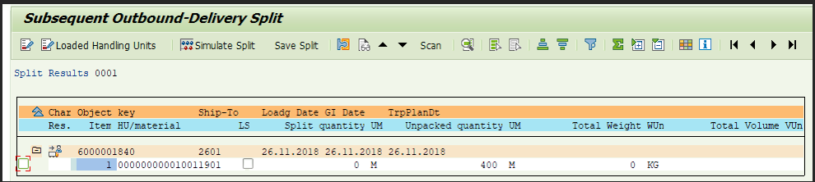

- Simulate Split
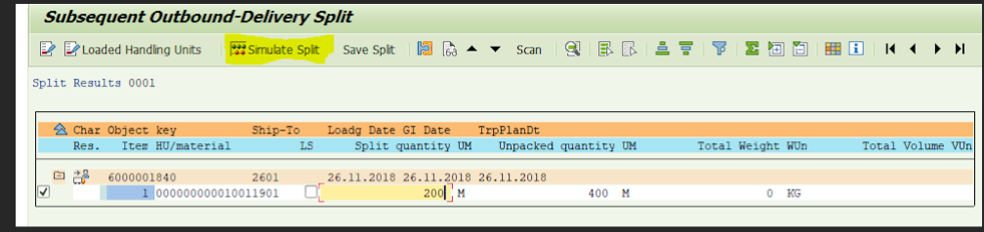

- Once, Simulate Split is clicked ..
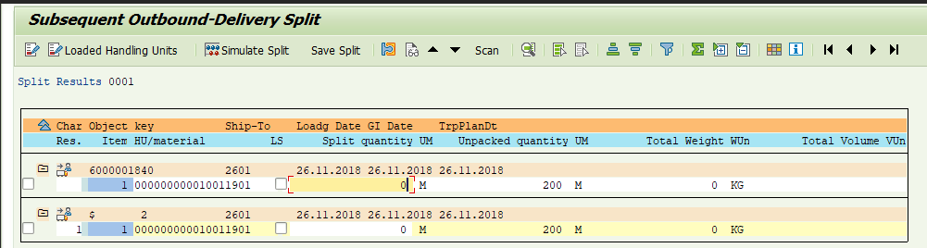

- Save Split
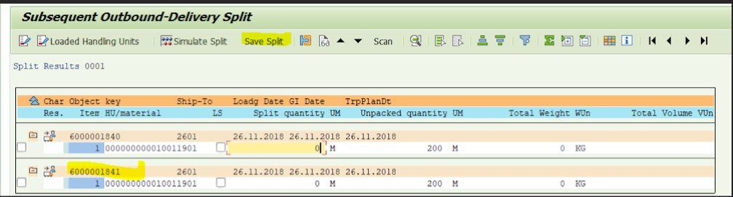

HOW TO TAKE PRINTOUT FOR THE MATERIAL INDENT
Note:- Print out can be taken for the indent only after allotment order is
given and out bound
- In the above statement we can get the allotment order (Purchase Order) number.
- Go to “ME23N” enter the purchase order no. and go to “PURCHSE ORDER HISTORY” tab and note down the “OUT BOUND DELEIVERY” number.
- Go to “ZMR_PRINT” and enter the out bound delivery number and click Execute icon and take out the print.
Note: - BASED ON THE OUTBOUND DELIVERY NO. THE STORES PEOPLE WILL
ISSUE THE MATERIAL THEN THE MATERIAL WILL BE IN TRANSIT. IN
ORDER TO TAKE IN TO STOACK THE MATERIAL IS TO BE “RECIVED”.

HOW TO RECEIVE THE MATERIAL IN TO STOCK AFTER ISSUE BY STORES
Note: - This procedure is same as goods receipt done for material I.e. 103
movement, but movement type is “101” and in place of inbound
delivery select out bound delivery.
- Go to MIGO and select “GOODS RECEIPT”, “OUTBOUND DELIVERY” and movement type “101” and execute
- In quantity tab check item ok check box and save the document

DEVOLUTIONS

- Check whether the material to be devoluted are available in the storage location of concerned EE/CONST
- To check the material stock ,go to “MB52”
- Enter plant ( CIRCLE CODE EX: SE/OMC/Tirupati : 3203)
- Enter storage location of concerned EE
- Check “Also select Special Stock”, Enter Special Stock Indicator “Q”
- Check “No Zero “Stock lines”
- In display options select “Non-hierarchical Representation” and Layout “/PS”
- Execute (press clock icon or press F8 )

IF MATERIALS ARE AVILABLE IN THE EE’S STORAGE LOCATION
THEN CREATE DEVOLUTION ORDER AS FOLLOWS

- Go to “ME21N”
- Select Document type ( Left side Vendor field) “ZDEV” i.e. Devolution Order
- Enter Supply plant i.e. plant where material is available
- Enter purchase organisation, purchase group and company code in “Org Data” tab
- In the item overview in column enter the following data
Column Data

A enter Q ( or select from list )

“I” enter U (or select from list )

Material material code

PO Quantity Enter Quantity

Plant enter concerned tlc stores code where
material is supposed to be devoluted

Note:- After entering data in each column if u press enter button in the key board the system will automatically guides you to the column where next data is to be filled.

In the item details in the account assignment tab enter the WBS element where the material is available. Then check ( This is small icon available in the line above the supply plant field ) and save and note down the devolution order number.

IF MATERIALS ARE NOT AVILABLE IN THE EE’S STORAGE LOCATION
i.e. MATERIALS ALREADY BEEN ISSUED TO THE PROJECT IN IFS ERP

- Furnish the material details which are left over physically and are to be devoluted to stores in the following format to project system team duly mentioning the details of requirement.

1. Material SAP code
2. Material description
3. Unit ( as per SAP )
4. quantity
5. Rate per each unit including taxes
6. WBS element where materials are to be created
7. Plant ( SE OMC )
8. Storage location ( EE’s)
2. After materials are created the same will be intimated to you and devolution
order is to be created as per the procedure mentioned above.

AFTER CREATING THE DEVOLUTION ORDER MATERIAL IS TO BE RELEASED FROM WBS ELEMENT AS FOLLOWS
After creating the devolution order the stores person cannot receive the material unless the material released from the WBS element by the devolution authority. For this following procedure is to be followed.
- Go to T-Code MIGO
- Select “GOODS ISSUE”
- Select “PURCHASE ORDER”
- Enter the Devolution order no. beside Purchase order filed
- Select movement type 351
- Enter following data in the tabs mentioned against each

TAB DATA
Material: Enter material code
Quantity: Enter quantity
Where: enter WBS element, Plant and storage location
Ensure in where tab Movement type 351 and Q
Now Check and post. Thus material will be in transit. Stores person can receive the material.
You can check the transit material through T code “ MB5T”

HOW TO TRANSFER THE MATERIAL FROM ONE CIRCLE TO ANOTHER CIRCLE

There will be requirement to transfer the materials from one project to another. There may be following cases.

- Transferring the material from one project to another with in the same division
- Transferring the material from one project to another in the same circle between constructions divisions
- Transferring the material from one project to another in the same circle between constructions division and O&M Division
- Transferring the material from one project to another between two circles between constructions divisions or Construction & O&M Division
For case 1, 2 & 3 the material can be transferred simply using transfer posting using T code “MIGO”. The procedure is as follows. For case no.4 follow the material Indent procedure as mentioned in the first page of this document.

STOCK TRANSFER POSTING
- Go to T code “MIGO”
- Select “Transfer Posting”
- Select other
- Select Movement type “415 Q”
In the transfer posting tab there are two areas
1. From (where material is available)
2. Dest (Where material is to be transferred)
enter the data in the two areas as mentioned below
From: Dest:
material code Storage Location
Plant WBS Element
Storage Location
WBS Element
Quantity
Click the CHECK button at the top if document is ok then click POST button
HOW TO ISSUE THE MATERIAL FORM STORAGE LOCATION TO PROJECT
(CLEARING OF MATERIAL FORM EE’s SATORAGE LO1CATION)
Material supplied by the contractor or drawn from stores or form other projects will be available at EE’s storage location. These material after being erected has to be issued to the project. Material which is not erected need not to be issued to the project. Issuing to the project means converting the material to CWIP (Capital Work InProgress). The Procedure for issuing the material to the project is as follows.
- Material is be issued to the project against M-book page no. in which concerned labour portion pertaining to that material is being recorded. Hence note down the M-book page and item number in that page pertaining to a material which is to be issued to the project.
- Go to t-code MIGO. Select “Goods issue”, “Other” and movement type “221 Q”
- In the material tab enter the material code
- Enter quantity in the quantity tab (Check the unit in the stock. For example, for conductor in SAP the stock will be in meters.
- In the “Where” tab enter plant, storage location
- Click the Doc. Header Text field and press F4 and select the M-book page and concerned item number.
- Then Check if everything ok, then POST.
- Check the stock in the T-code MMBE whether stock is cleared.

